T-Shirt Station
Directions: You are given 2 shirts. On one, half of the shirt has been treated with a nano protectant spray and the other half has not been treated at all. They are labeled with “nano” and “not nano”. The other shirt (“Threadsmiths”) has been embedded with nanoparticles.
Try pouring the liquids provided on each shirt and make observations. Please pour the liquids over the bucket provided.
Questions
- Why do you think this is occurring?

- What differences do you notice between the three shirts?

Nano Ethics: Nano-Coating
Go to the following website: http://nanoyou.eu/dilemmas5grade1418 (also linked on BlackBoard)
Read through the problem solution and effect.
Question
What are the advantages and disadvantages of using nanomaterials as a coating?
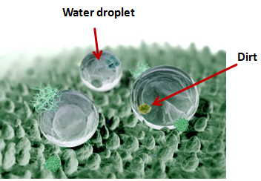
Explanation:
Most clothing gets wet when water is spilled on it like one of the shirts provides but the other shirt has nano-sized compounds on it make of silica. These nanoparticles are hydrophobic, meaning they repel water causing the shirt to be water resistant. The angle and texture/roughness of the silica coating cause the liquid to form beads and roll off of the shirt as shown in the figure to the right. This is called the “lotus effect” since it acts similarly to how water rolls off of some plant leaves.
Other example:
- Sprays including zinc oxide, titanium dioxide and antimony-doped tin oxide nanoparticles can be used to reduce the static charge fabrics like polyester and nylon tend to gather. These particles conduct electricity which works to disperse the charge.

Questions to Consider:
- How does this activity relate to size-dependent properties?

- How does this concept relate to electromagnetic forces?

- How will you assess your students on this concept?

- What do you think could be some of the risks associated with using nanoparticles in clothing?

References:
http://www.nisenet.org/catalog/programs/exploring_products_-_nano_fabrics_nanodays_10_11
http://silicshirts.com/about-silic-waterproof-shirts/
http://www.theguardian.com/science/small-world/2014/feb/14/nanotechnology-clothes-nanoparticles
https://www.teachengineering.org/view_lesson.php?url=collection/duk_/lessons/duk_surfacetensionunit_lessons/duk_surfacetensionunit_less4.xml
http://nanoyou.eu/en/component/content/article/87-hands-on-activities/502-experiment-with-superhydrophobic-materials.html?directory=4&Itemid=4 (handouts and worksheets)

Plant Station
You are given lettuce leaves, kale leaves and broccoli. Examine the surface of these three different plants. Pour water on them over the bucket provided and make observations.
Questions:
- What differences do you notice between the surfaces of the three plants?

- What happens to the water when you pour it on each plant?

- Why do you think this is occurring?

Explanation:
As you can see, the water does not wet the surface of the kale or broccoli but rolls right off. On the other hand, the lettuce remains wet. This is due to the “lotus effect”. Plants like the lotus, kale and broccoli have a superhydrophobic surface, meaning water repelling. The leaves of these plants have nano-sized waxy bumps on their leaves. The water and dirt say on top of the bumps. This causes a lot of surface tension which causes the water to bead up. Not only does the water roll off, but it picks up and carries away materials like dirt and dust on the leaf. This is shown in the figure above.
Scientists have been working on mimicking this property on a variety of materials, such as clothing, house paint with silicon nanoparticles, ceramic roof tiles and architectural glass. All of these display hydrophobic and self-cleaning properties.

Questions to Consider:
- How does this activity relate to size-dependent properties?

- How does this activity relate to the other concepts we have covered (size and scale, SA/V, forces)?

- What background knowledge do you think your students will have with this concept?

  - How will you find that out?

References:
https://www.teachengineering.org/view_lesson.php?url=collection/duk_/lessons/duk_surfacetensionunit_lessons/duk_surfacetensionunit_less4.xml
http://www.nisenet.org/catalog/programs/exploring_products_-_nano_fabrics_nanodays_10_11
https://www.teachengineering.org/view_lesson.php?url=collection/duk_/lessons/duk_surfacetensionunit_lessons/duk_surfacetensionunit_less4.xml
http://www.nanowerk.com/spotlight/spotid=19644.php
Sand Station
Directions:
You are provided with magic sand (blue or pink) and regular sand. Pour a little of the sand on each plate and play around with it and both the water and oil provided.
Questions:
- What do you notice about how both the magic sand and regular sand interacts with both liquids?

- Why do you think this occurs?

Waste:
- Pour as much water and oil you can into the large beaker provided (labeled “Waste”)
- The sand with oil in it can go back on the paper towels/plate labeled “Oil” and the sand with water in it can go on the paper towels/plates labeled “Water”.

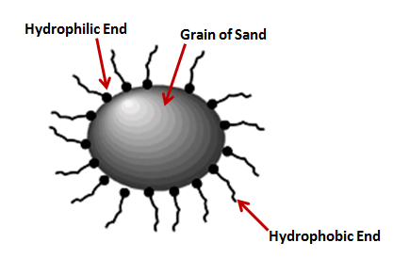
Explanation:
In magic sand, individual grains of sand are coated with an oil-like substance. Because of this, the water becomes hydrophobic. Since water is polar, it does not mix with non-polar compounds like oils, fats, tar or vegetable oil. This occurs because the interactions between water molecules are so strong. It does not mix with non-polar compounds, so it can continue to interact with other water molecules. These nonpolar substances are said to be hydrophobic, and repel water. Substances that mix with water, polar substances, are said to be hydrophilic, and attract water. Naturally sand is hydrophilic but since this sand has been coated with an oil-like substance, it has become hydrophobic and repels the water.
The coating of each sand grain is a silicon-based compound with one end that attracts to the sand particle and the other end, which sticks out away from the sand, is hydrophobic. This creates a hydrophobic surface around each grain of sand.
Magic sand was originally created to clean up oil spills. It is currently being used by utilities companies in the artic so they can repair buried equipment. With the magic sand buried around the equipment, it repels water and does not allow the ground to freeze there. It is also used to hold water near plant roots in desert climates.

Questions to Consider:
- How do you think magic sand would help to clean up oil spills?

- How does this activity show size-dependent properties?

- What does this activity have to do with the concept of electromagnetic forces that we learned about yesterday?

- How could you use this activity in your PBL unit?

- What do you think could be some of the risks associated with using “magic sand” commercially?

References:
http://www.nisenet.org/catalog/programs/magic_sand_nanosurfaces
http://ice.chem.wisc.edu/Oil/On_The_Surface,_Its_All_About_Nano/Magic_Sand.html
http://www.scielo.br/scielo.php?script=sci_arttext&pid=S0103-97332005000400018 (picture)

Iron Station
Safety:
WEAR GOGGLES
DO NOT OPEN VIALS
Directions:
You are provided with both ferrofluid and magnetite. Ferrofluid is a nanoscale form of iron and magnetite is a microscale form of magnetite. Without opening the vials, play around with both materials and the magnets provided.
Questions:
- What differences do you notice between the two materials?

- Why do you think this occurs?

Explanation:
Ferrofluid and black sand are both made of magnetite, or iron oxide (Fe₃O₄). Ferrofluid consists of approximately 10 nanometer-sized particles suspended in a liquid medium often containing a surfactant. The iron in the ferrofluid will only respond when exposed to a strong magnetic field. They are also so small they stay suspended in solution, meaning that gravity does not pull them down. Black sand consists of macroscopic grains of magnetite.
Ferrofluids were discovered by NASA in the 1960s as they investigated how to control liquids in space. They have been used in loudspeakers to reduce the heat and unwanted resonances from the electric coil. Researchers are working on designing ferrofluids to carry medication to different parts of the body as well as using it as a contrasting agent for magnetic resonance imaging (MRI). Black sand, on the other hand, is found naturally around the world. It can be found at the bottom of streams and lakes as well as in many desert sands. It is commonly used to make steel as well as making abrasives, cements and paints.

Questions to Consider
- What role/s do you think the electromagnetic and gravitational forces play in these differences in properties between ferrofluid and black sand?

  - Why do you think a liquid medium with a surfactant is used for the ferrofluids?

- What role/s do you think surface-area-to-volume ratios play in the differences in properties between ferrofluids and black sand?

- What do you think could be some of the risks associated with using ferrofluid for commercial use?

References:
http://nanosense.sri.com/activities/sizematters/properties/SM_Lesson3Student.pdf
http://www.exo.net/~pauld/summer_institute/Nano%20Institute/Day4/ferrofluid%20guide.pdf
http://www.nisenet.org/sites/default/files/catalog/uploads/1990/materialsferrofluid_guide_14nov13.pdf
http://education.mrsec.wisc.edu/background/ferrofluid/
http://ormuswater.vpinf.com/magnetite-sand-1.html#intro
Gold
Safety:
WEAR GOGGLES
Directions:
You are given 2 test tubes with gold nanoparticles. Use the light provided to explore its properties. (Do not spill). Add a little salt to one of the test tubes and a little sugar to the other test tube. Make observations.
Questions:
- What do you notice about how nanoscale gold interacts with light?

- What occurs when you add salt to the nanoparticle solution? What about the sugar?

- Why do you think this occurs?

Waste:
Pour both solutions into the waste bucket in the hood. Rinse the test tubes with DI water once into the waste bucket and then put them by the sink.

Nano Ethics: Nano Toothbrush
Go to the following website: http://nanoyou.eu/dilemmas2grade1418 (also linked on BlackBoard)
Read through the problem, solution and effect.
Question
What are the advantages and disadvantages of using nanoparticles in toothbrushes?
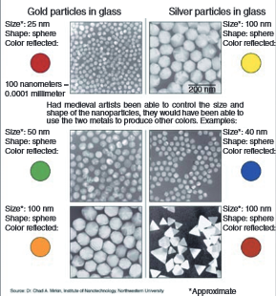
Explanation:
The use of nanoparticles in materials dates back to the ancient and medieval times. For example, Romans used nanoparticles in the fourth and fifth century in the Lycurgus cup. The Lycurgus cup is a Roman cup that had gold and silver nanoparticles between 50 and 100 nm within the glass part of the cup. These particles allow the glass to appear green when lit from the outside and appear red when lit from the inside.
Differing sizes of the same element or compound can display different properties such as color. The image to the right shows how the differing sizes of gold and silver nanoparticles reflect different colors.
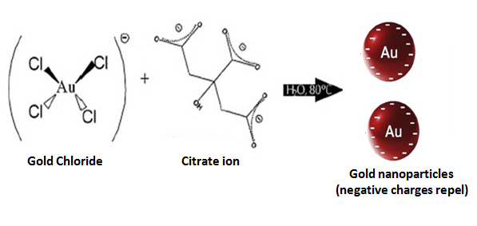
The gold nanoparticle solution given to you is made adding sodium citrate (Na₃C₆H₅O₇) to a gold chloride solution (HAuCl₄). The citrate anions adsorb or attach to the surface of the nanoparticle, causing the nanoparticles to repel each other. Adding the salt (NaCl) to the nanoparticle solution has an effect since salt is a strong electrolyte. This means that the salt breaks into its sodium (Na⁺¹) and chloride (Cl⁻¹) ions. The ions reduce the electrostatic repulsion between the nanoparticles and the nanoparticles aggregate, or combine. As the space between nanoparticles decreases, the color changes. If enough salt is added, the nanoparticles will precipitate or solidify. The sugar (C₁₂H₂₂O₁₁) is not an electrolyte so it has no effect on the nanoparticle solution.
Gold nanoparticles can be used as a cancer treatment and for biological imaging. It can also be used as a biomarker to diagnose diseases like heart disease and cancers. It is a common component of home pregnancy tests. It also has uses in fuel cells and electronics.
Other Example:
Macroscale silver is non-toxic but silver nanoparticles kill viruses upon contact. Nanosilver socks have been developed which contain silver nanoparticles used because of its antibacterial properties.

Questions to Consider:
- How do gravitational and electromagnetic forces play a role in the differences in properties from the macroscale and nanoscale?

- How does the surface-area-to-volume ratio play a role in the differences in properties from the macroscale and nanoscale?

- What do you think could be some of the risks associated with using gold nanoparticles commercially or for medical purposes?

References:
http://www.wiley-vch.de/books/sample/3527331972_c01.pdf
http://nanosense.sri.com/activities/sizematters/properties/SM_Lesson3Student.pdf
http://www.nanosilver.eu/Tema/Why-Nanosilver/Magical-Socks-Nanosilver-with-Silver-Nanoparticles
http://www.ifsc.usp.br/eng2/index.php?option=com_content&view=article&id=21&Itemid=15&rowid=390 (gold synthesis picture)
http://mathinscience.info/public/does_all_gold_glitter/synthesis_of_gold_nanoparticles_old.doc (gold nanoparticle synthesis activity)
http://nanoyou.eu/en/component/content/article/87-hands-on-activities/501-experiment-with-colorimetric-gold-nanosensor.html?directory=4&Itemid=4 (background info and synthesis procedure)

Crystal Sheets Station
Directions:
You are given 3 different crystal sheets labeled “A”, “B” and “C”. Touch the sheets with your hands and the hot and cold materials provided to make observations.

Questions:
- What differences do you notice between the three sheets provided?

- How do you explain the observations you are making?

Nano Ethics: Future Light Source
Go to the following website: http://nanoyou.eu/dilemmas6grade1418 (also linked on BlackBoard)
Read through the problem, solution and effect.
Question
What are the advantages and disadvantages of using nano-crystals as a light source?
Explanation:
These are temperature sensitive liquid crystal sheets. Their temperatures range from 25-30°C (A), 30-35°C (B) and 35-40°C (C). The molecules occur in a fourth state of matter: liquid crystal (LC). In this phase, the material acts both as a liquid and a solid by allowing the molecules to move independently but to remain somewhat organized. This means the liquid crystals are both fluid-like liquids but also contain optical and electrical properties like some solids. The liquid crystals change color based on a specific temperature range due to the movement of the material from solid phase to liquid phase. This temperature range can change based on the amount of cholesteryl oleyl carbonate and cholesteryl pelargonate used to make the liquid crystals.
Liquid crystals can be found in cell phone displays, laptop computer screens and are being used in nanosensors. Nanosensors are small devices that change in response to the environment.

Questions to Consider:
- How does this activity show size-dependent properties?

- How could you use this activity in your classroom?

- What misconceptions do you think students will have with this concept?

- What do you think could be some of the risks associated with using liquid crystal sheets commercially?

References:
http://www.nisenet.org/sites/default/files/catalog/uploads/1989/materialslc_sign_15nov10.pdf
http://nanoyou.eu/en/component/content/article/87-hands-on-activities/500-experiment-with-liquid-crystals.html?directory=4&Itemid=4 (background information, student synthesis procedure and video)

Sunscreen Station
Directions:
You are given both a sunscreen with zinc oxide nanoparticles and one with non-nano zinc oxide particles. Use the black paper provided (or the CD jewel cases) to observe the transparency of each lotion. Only use a small amount of each lotion and then you can use the Q-tips to rub the lotion onto the paper/case.
(You can rub a small amount on your arm as well.)

Waste:
Throw the used construction paper/CD jewel cases and Q-tips in the trash.

Nano Ethics: Nano Sunscreen
Go to the following website: http://nanoyou.eu/dilemmas3grade1418 (also linked on BlackBoard)
Read through the problem, solution and effect.
Question
What are the advantages and disadvantages of using nanoparticles in sunscreen?
Explanation:
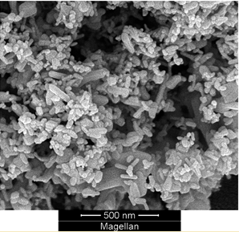
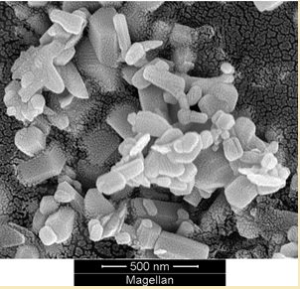
The sunscreen lotions both contain zinc oxide but one contains zinc oxide nanoparticles. The regular zinc oxide leaves a visible film since the particles are large enough to reflect visible light. The nano-sunblock appears transparent since the nanoparticles are too small to reflect visible light (400-780 nm) but still large enough to absorb UV radiation (400-100 nm). Zinc oxide nanoparticle in sunscreen typically range from 10-100nm in diameter where their chemical and physical properties stay the same but optical properties differ. A scanning electron microscope image of the non-nano zinc oxide is shown on the left and one of nano zinc oxide is shown on the right.

Questions to Consider:
- How does this activity show size-dependent properties?

- How does this activity connect to the other concepts we have learned in the workshop?

- What do you think could be some of the risks associated with using zinc oxide nanoparticles commercially?

References:
http://www.nisenet.org/catalog/programs/invisible_sunblock
http://www.badgerbalm.com/s-33-zinc-oxide-sunscreen-nanoparticles.aspx
Stevens, S. Y., Sutherland, L. M., & Krajcik, J. S. (2009). The big ideas of nanoscience and engineering: A guidebook for secondary teachers. Arlington, VA: National Science Teachers Association Press. (pg.41)

