Black Box Activity
Introduction
As early as the 1980s, scientists have been developing instruments that can both measure and manipulate objects on the nano and atomic scales. If you close your eyes and run the tip of your finger across a surface, you are able to tell different features about a surface. Instruments used to measure the nanoscale work in a similar way. They have a probe that slides across a surface and measures properties like force.
Atomic Force Microscopy
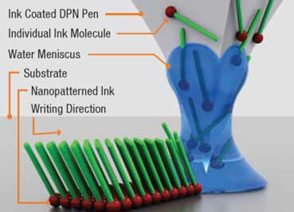
Atomic force microscopy (AFM) works by measuring the forces of attraction and repulsion (van der Waals forces) between the tip of the instrument and the sample being measured. The tip of the AFM is attached to a cantilever to allow it to move as it is attracted or repelled from the surface. A laser beam is then used to measure the movement of the cantilever.
The AFM has recently been used in dip pen nanolithography (DPN) which allows scientists to write structures to a surface the way you would write ink to a piece of paper. They store atoms or molecules in the tip of an AFM and then move the tip across a surface, leaving structures behind. This technique allows for advances in DNA patterning, fabricating biological nanoarrays (to screen for targets such as the HIV virus) and electronics.
Scanning Tunneling Microscopy
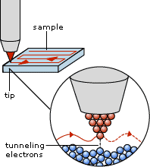
Scanning tunneling microscopy (STM) works through a phenomenon known as electron tunneling. Electron tunneling is the movement of an electron through a forbidden state. Since electrons have properties of both waves and particles, there is a probability that it will move through a forbidden energy state. (An analogy of this would be the probability that a roller coaster car at the bottom of a large hill will make it to the top. If it is not provided enough energy, it cannot make it over the hill. If the car were an electron, there would be a probability that it would “tunnel through” the hill to the other side.)
The STM works by having a small tip, or probe, brought to within 1 nm of an electrically conducting surface. The current is measured as a result of the electron tunneling which is very sensitive to gap distance. As the distance between the probe and surface changes, the current will change. Scientists either measure the topography of a surface by keeping the height constant and measuring the change in current or keeping the current constant and measuring the change in height.
This instrument not only allows scientists to obtain images of the nanoscale, but by applying small voltages to the STM tip, they can manipulate individual atoms. For example, Don Eigler and his team used the STM to manipulate xenon atoms to spell out “IBM”.

In this activity, you will explore what it is like to model a surface you are unable to see with your eyes.
Materials
- Mystery box (DO NOT OPEN)
- Wooden skewers
- Graph paper
- Ruler
- Marker
Procedure
Your goal is to draw a model of the surface inside the box without opening the box. You will use the wooden skewers to probe the surface and then draw a model of the surface on graph paper provided.
Extension:
Once you have completed the activity, learn more about the STM and AFM at the following YouTube videos/websites:
https://www.youtube.com/watch?v=oSCX78-8-q0 (world’s smallest movie: boy and his atom)
https://www.youtube.com/watch?v=xA4QWwaweWA (making of world’s smallest movie-application of STM)
https://www.youtube.com/watch?v=KJQ_h7LTotU (biological applications of dip pen nanolithography
http://virtual.itg.uiuc.edu/training/AFM_tutorial/ (STM and AFM)
https://www.youtube.com/watch?v=NWWkZ2ILNmA (STM)

Questions to Consider
- What difficulties did you have with this activity?

- What are the limitations of your model of the surface inside the box?

- What are the benefits and limitations of using this method to determine the surface inside the box?

- How does this activity relate to how scientists study the nanoscale?

  - What challenges do scientists have when studying the nanoscale?

  - How does this activity relate to the STM and AFM described in the introduction?

- How does this concept relate to the concepts we have covered so far (size and scale, surface-area-to-volume ratio, and forces)?

- How do models like this help scientists better understand the nanoscale?
References
http://sciencelearn.org.nz/Contexts/Nanoscience/Teaching-and-Learning-Approaches/Seeing-the-invisible
https://sites.google.com/a/fatherjudge.com/ret-nano-2011/lesson-plan
http://nanosense.sri.com/activities/sizematters/tools/SM_Lesson4Teacher.pdf
davinci.lib.uoguelph.ca/article/download/1351/2054 (nanolithography)
http://www.scitech.com.au/index.php?page=nanoink (nanolithography image)
http://www.teachnano.com/education/AFM.html (AFM image)
http://teachers.stanford.edu/activities/ForceMicroscopy/ForceMicroscopy.pdf
http://phys.org/news173344987.html (IBM image)
http://www.ieap.uni-kiel.de/surface/ag-kipp/stm/stm.htm (STM image)

