“Does it Pour Out?” Activity
Connection to NGSS
- HS-PS1-3. Plan and conduct and investigation to gather evidence to compare the structure of substances at the bulk scale to infer the strength of electrical forces between particles.
- HS-PS2-4. Use mathematical representations of Newton’s Law of Gravitation and Coulomb’s Law to describe and predict the gravitational and electrostatic forces between objects.
Introduction
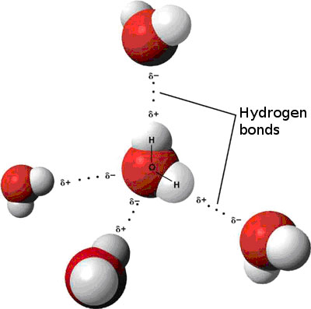
Electrostatic forces involve the interaction between the charges of two objects. Sometimes those objects have permanent charges such as a sodium ion (Na⁺¹) or chloride ion (Cl⁻¹). Other times molecules are electrically neutral but the distribution of charge within the molecule is not even and this leads to charge build up in one part of the molecule. This is called a dipole moment and these molecules are considered polar. The partially negative part of that molecule is attracted to the partially positive part of the surrounding molecules. In the case of water (H₂O), the oxygen is partially negative (δ-) so it is attracted to the partially positive (δ+) hydrogens of other water molecules. The attraction of these water molecules to each other is called van der Waals attraction. This interaction can be seen in the figure to the right.
Two properties of water include cohesion and adhesion. Cohesion is the attraction of water molecules to other water molecules. Cohesion can be observed through the clumping of water to make droplets, as seen in the picture on the left below. The cohesive force between water molecules causes the surface tension. An example of surface tension is the ability of small insects to walk on top of water. Adhesion is another property of water. Adhesion is the attraction of water to other substances. An example of this is water sticking to the end of pine needles as seen below on the right.
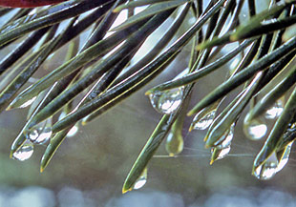
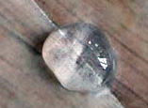

In this activity you will explore how gravitational and electrostatic forces affect water in different situations.
Safety
- Wear goggles during lab investigation.
- DO NOT eat or drink in the lab
- Handle glassware with care.
Materials
- Large test tube
- Small test tube
- Water
- Pipette
- Modelling Clay
- Toothpicks, Pencils, Dowels
- Plastic container
Procedure
- Predict what will happen when a small test tube and a large test tube are filled with water and then the water is poured out of each tube.

- Test your predictions.

- Using clay, design and build a cup that can hold the largest amount of water without the water pouring out when the cup is tipped. *Winning group gets a prize!*

Extension Activity:
Using clay, design and build cups with different shapes and sizes to explore the reasoning behind the observation you made with the small and large test tubes.
Questions to Consider
- What differences do you notice between how the water pour out of the large test tube versus the small test tube?

- How does the shape and size of the container affect whether or not liquids pour out from the containers?

- What do you think is the reasoning behind the observations you are making?

  - How does this activity relate the gravitational vs. electromagnetic activity?

- What factors did you consider when building your own cup in step 3?

- How would you connect the observations made in this activity to the nanoscale?

- Geckos are able to walk upside down, against gravity, on many different substances since their feet are made up of millions of nanostructures called setae. How do electromagnetic forces play a role in this phenomenon?

- How does this concept relate to the concepts we have covered so far (size and scale and surface-area-to-volume ratio)?

References
http://nanosense.sri.com/activities/sizematters/properties/SM_Lesson3Student.pdf
http://teachers.stanford.edu/activities/PourItOut/PourItOut-TeacherGuide.pdf
http://www.sciencepartners.info/?page_id=430 (structure of water visual)
http://water.usgs.gov/edu/waterproperties.html (cohesion/adhesion explanation and visuals)
Jones, M.G., Falvo, M.R., Taylor, A.R. & Broadwell, B.P. (2007). Nanoscale science: Activities for grade 6-12. National Science Teacher Association. 89-94.

