Surface Area to Volume Effects…What Affects Enzyme Activity?
Connection to NGSS
- HS-PS1-3. Plan and conduct and investigation to gather evidence to compare the structure of substances at the bulk scale to infer the strength of electrical forces between particles.
- HS-PS2-6. Communicate scientific and technical information about why the molecular-level structure is important in the functioning of designed materials.

Introduction
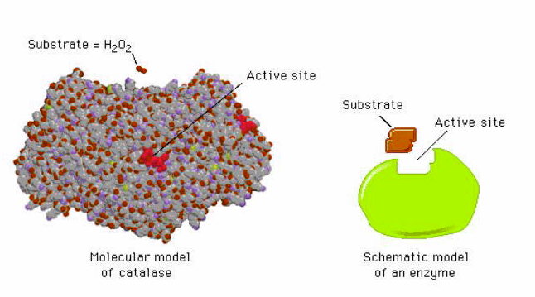
Catalysts are substances that increase the rate of a reaction without being consumed or chemically changed. This means the catalyst is recycled over and over again. Enzymes are biological catalysts and are used in thousands of reactions within the human body. The most important part of a catalyst is the active site. This is where the reaction takes place. The active site of the enzyme reacts with the substrate, the substance to be reacted.
Within many plant and animal tissues is an enzyme called catalase. This enzyme is used to protect the cells from damage by breaking down hydrogen peroxide (H₂O₂). Hydrogen peroxide is a common waste product from cellular metabolism and can be very toxic to cells. As it is broken down into water (H₂O) and oxygen (O₂) by the enzyme catalase, it is no longer toxic. The following is the reaction that is catalyzed by catalase to break hydrogen peroxide down.
(catalase)
2H₂O₂ (l) 2H₂O (l) + O₂ (g)
In this activity, you will be exploring how surface area affects the rate of decomposition of hydrogen peroxide into water and oxygen.
Safety
- Wear Goggles during this lab investigation.
- DO NOT eat or drink anything in the lab.
- Liquid waste can be poured into the bucket provided (to be poured down the drain).
- Solid waste can be put in the trash bucket.
- Hydrogen peroxide can damage your clothes. Rinse any spills with water immediately.
Materials
- Potato (unpeeled and uncut)
- Hydrogen Peroxide (3% by weight)
- Potato Peeler
- Knife
- Weigh boats
- Spatulas
- Stirring rods
- Balance
- Hot plate
- Stopwatch/Cell phone
- DI Water
- 400 mL beakers
- 100 mL graduated cylinder

Procedure
You are going to come up with your own investigation to answer the following question: how does surface area affect the rate of decomposition of hydrogen peroxide? Using the materials listed above, develop an experiment that can be used to answer this question. From your experiment, collect data to support your answer to this question.
Be prepared to briefly present the experiment you developed, the results you obtained and what they mean to the rest of the class.
Questions to Consider
- What relationship did you observe between the surface area and the rate of decomposition of hydrogen peroxide?

- What do you think is the reasoning behind this relationship?

- How does surface-area-to-volume ratio (SA/V) relate to the concept of size and scale?

- Based on your observations, what role do you think surface area plays for nanoscale objects?

References
http://www.ucvts.tec.nj.us/cms/lib5/NJ03001805/Centricity/Domain/274/What%20Affect%20Enzyme%20Activity%20Lab%20POST%20Lab%20Question%20ANSWERS.pdf
http://www.mrothery.co.uk/exchange/allkeynotesas.htm
http://www.huntington.org/uploadedFiles/Files/PDFs/GIB-UsingMathtoTalkAboutCellsAnswers.pdf
http://imgarcade.com/1/catalase-reaction/ (catalase image)

