Vincennes, IN Knox County; Latitude: 38° 40' 38" N, Longitude: -87° 31’ 43”

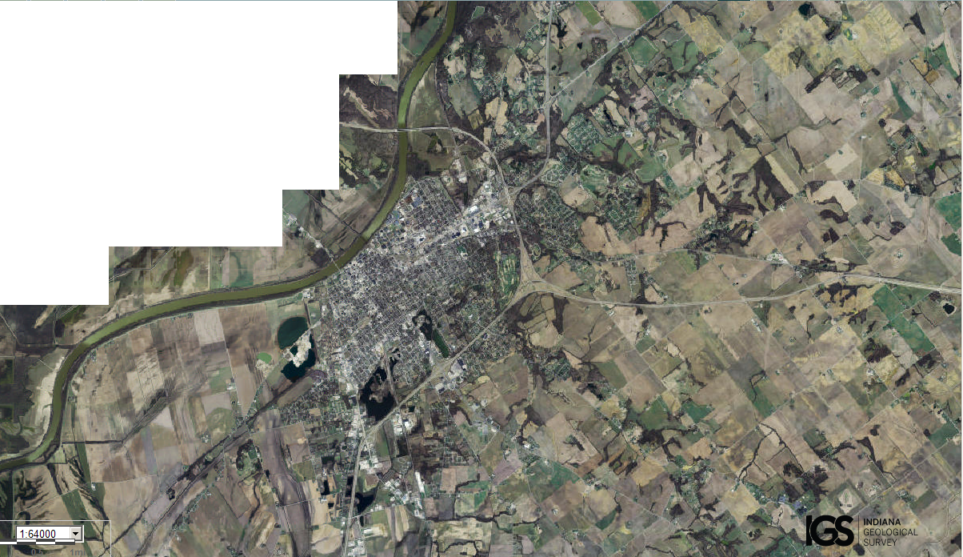
Assets: river, soils for growing food, fishing, flat terrain…
Liabilities: two bridges over the river, incoming roadways, minimal trees/forests, little hunting…

