Tell City, Indiana Perry County; Latitude: 37° 57' 5" N, Longitude: 86° 46' 4" W
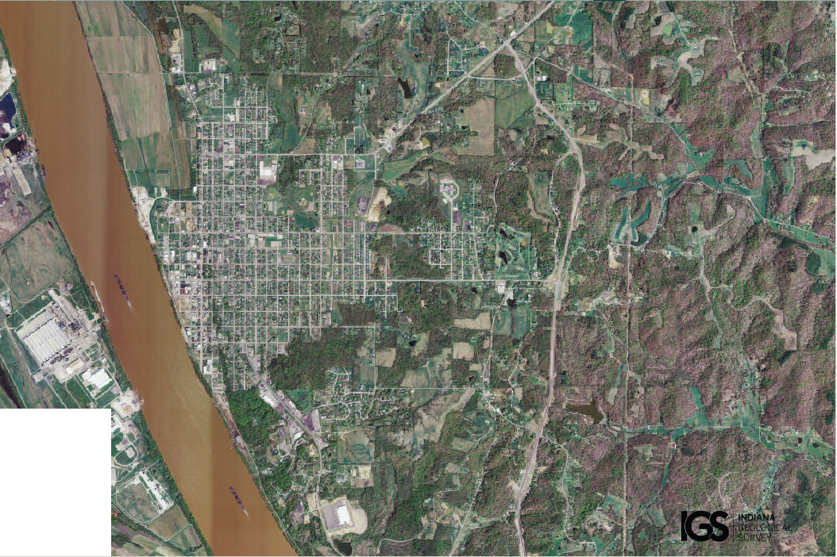
Assets: river, soil for growing food, hunting, fishing, industry across the river…
Liabilities: accessible from Louisville, Kentucky (a very large city), flooding

