Santa Claus, IN Spencer County; Latitude: 38° 7' 12" N, Longitude: -86° 54' 51" W

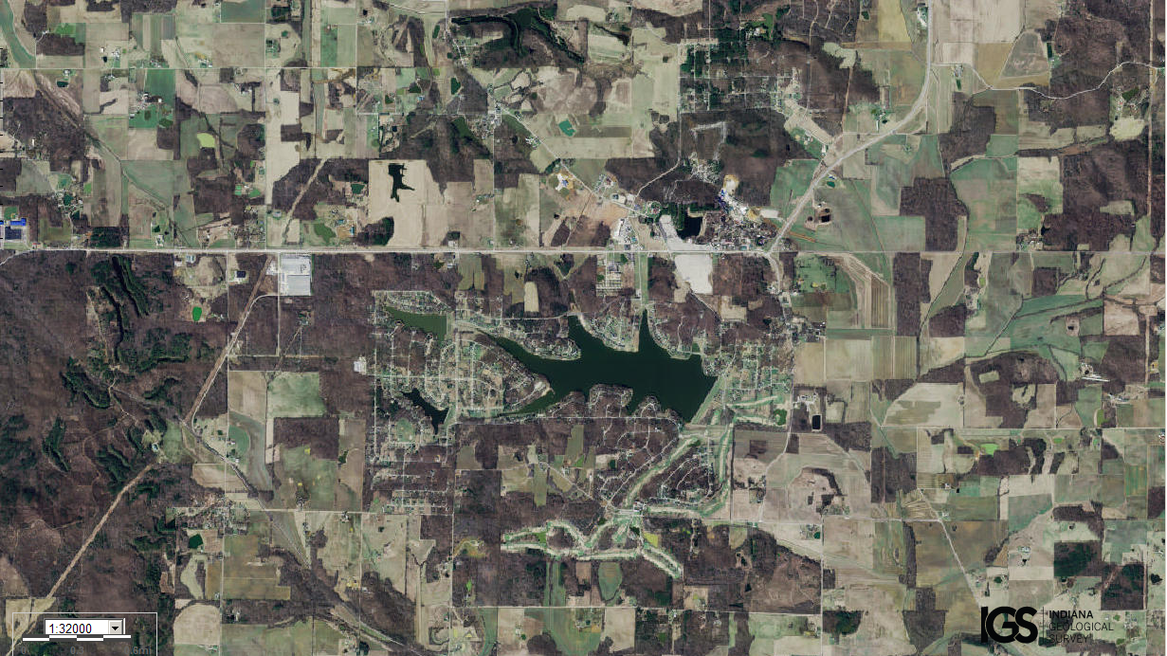
Assets: not too large and not too small, soil for growing food, fresh water, trees/forests, fishing?, hunting?...
Liabilities: area is spread out…

