New Harmony, IN Posey County; Latitude: 38.1286, Longitude: -87.9342
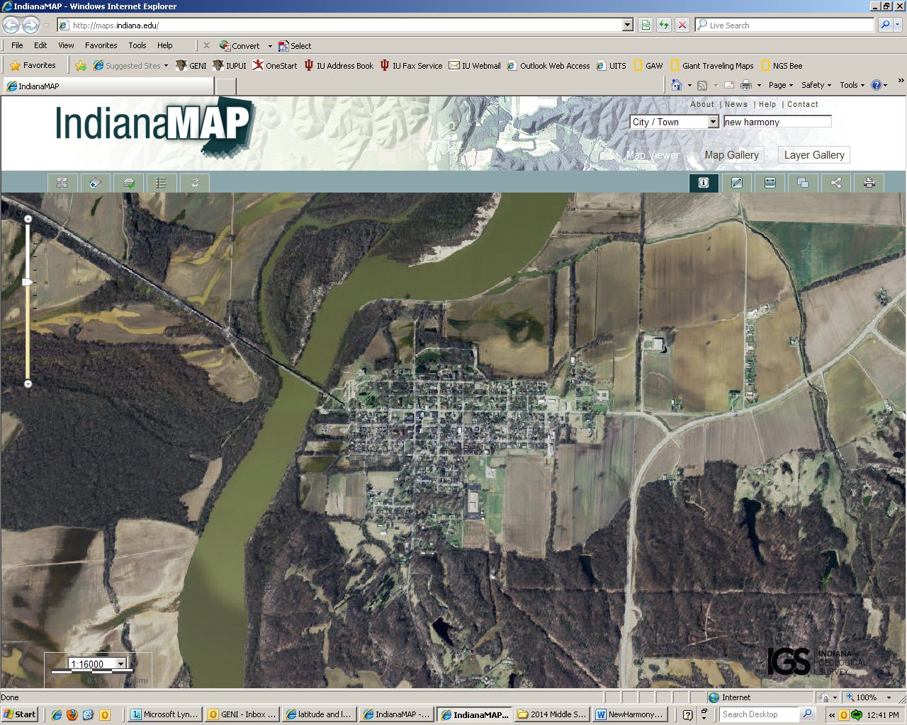

Assets: river, good soil, space to grow food, hunting, fishing…
Liabilities: small community, no wells, no grain storage, close to river (flooding)…

