Nashville, IN Brown County; Latitude: 39° 12' 26" N, Longitude: -86° 15' 4" W

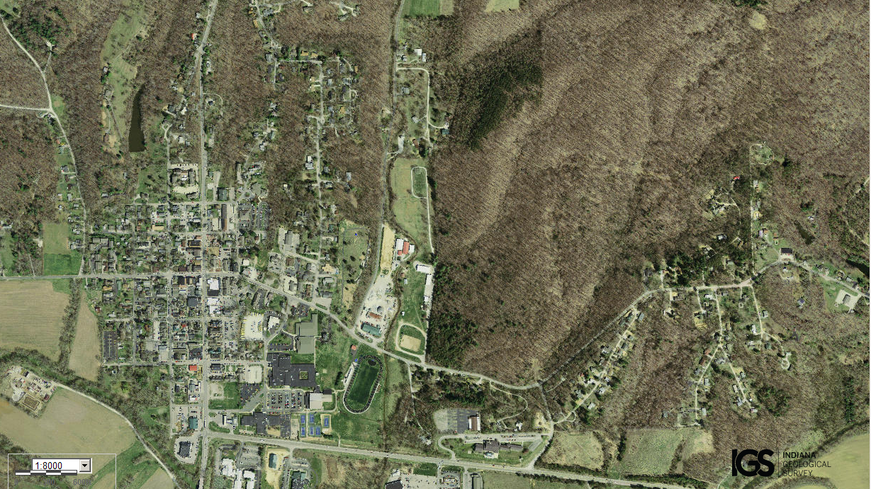
Assets: not too large and not too small, soil for growing food, trees/forests, hunting?, local high school…
Liabilities: area is spread out, lots of transportation routes in/out, hilly terrain…

