Michigan City, IN LaPorte County; Latitude: 41° 42' 27" N, Longitude: -86° 53' 42" W

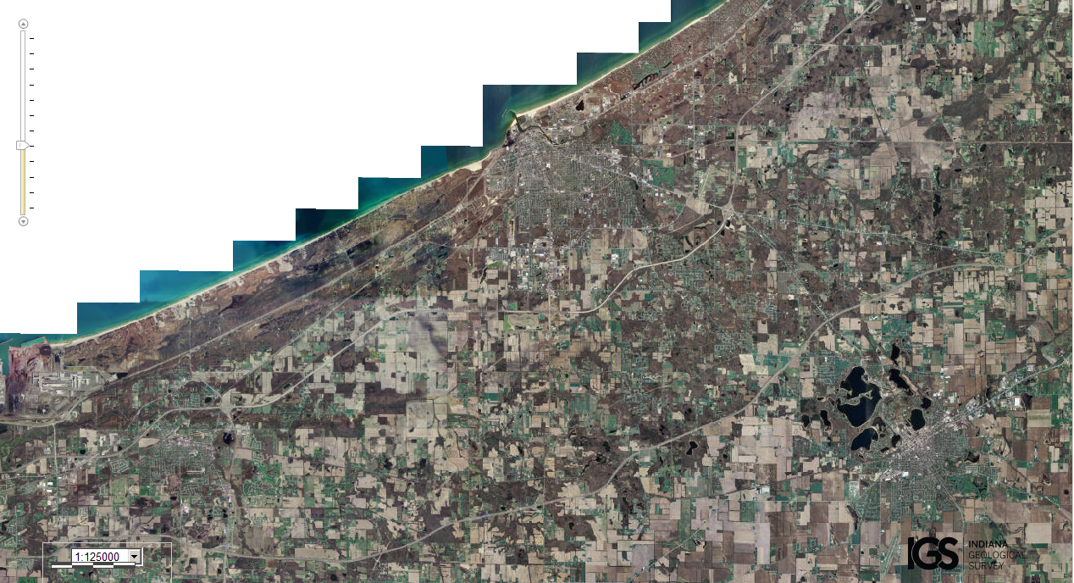
Assets: lots of people to help defend, soil for growing food, fresh water, fishing…
Liabilities: too large an area to defend, lack of enough trees/forests…

