Madison, IN Jefferson County; Latitude: 38° 44' 8" N, Longitude: -85° 22' 48" W

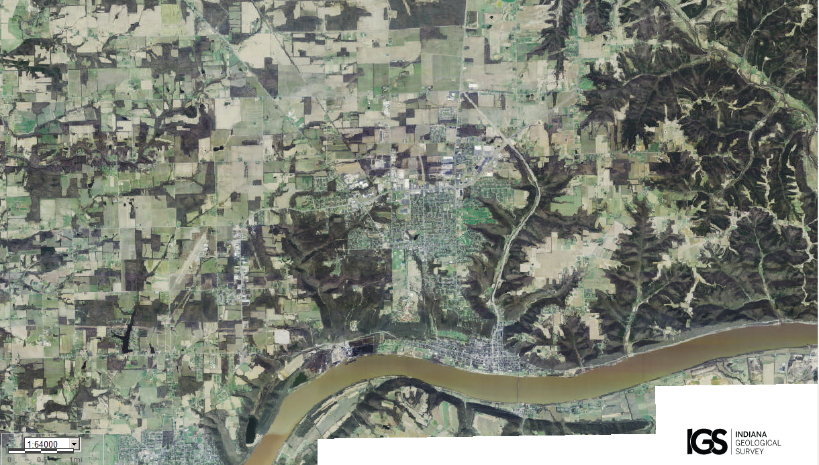
Assets: lots of people to help defend, soil for growing food, fresh water, fishing, forest, hunting
Liabilities: too large an area to defend, too many people, flooding…

