Delphi, IN Carroll County; Latitude: 40° 35' 15" N, Longitude: -86° 40' 30" W

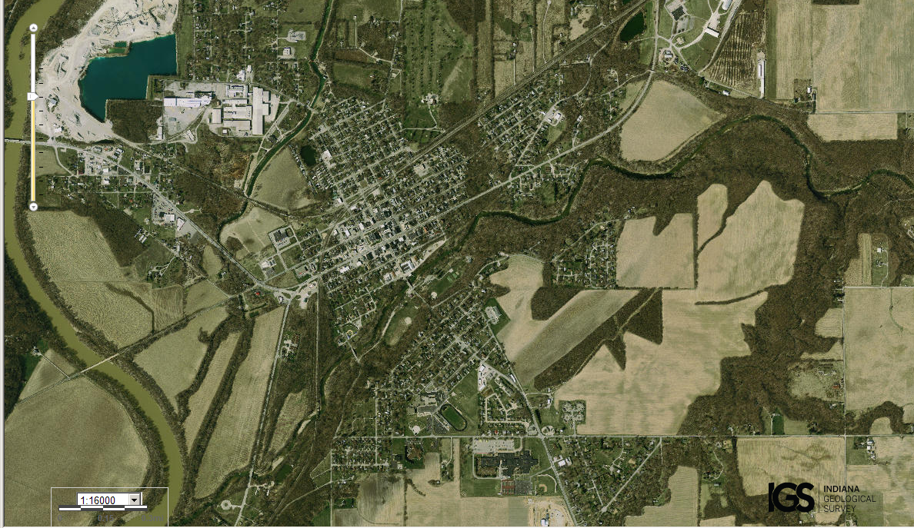
Assets: fresh water, gravel, soil, flat landscape…
Liabilities: few trees, flat landscape…

