Decatur, IN Adams County; Latitude: 40° 49' 50" N, Longitude: -84° 55' 45" W

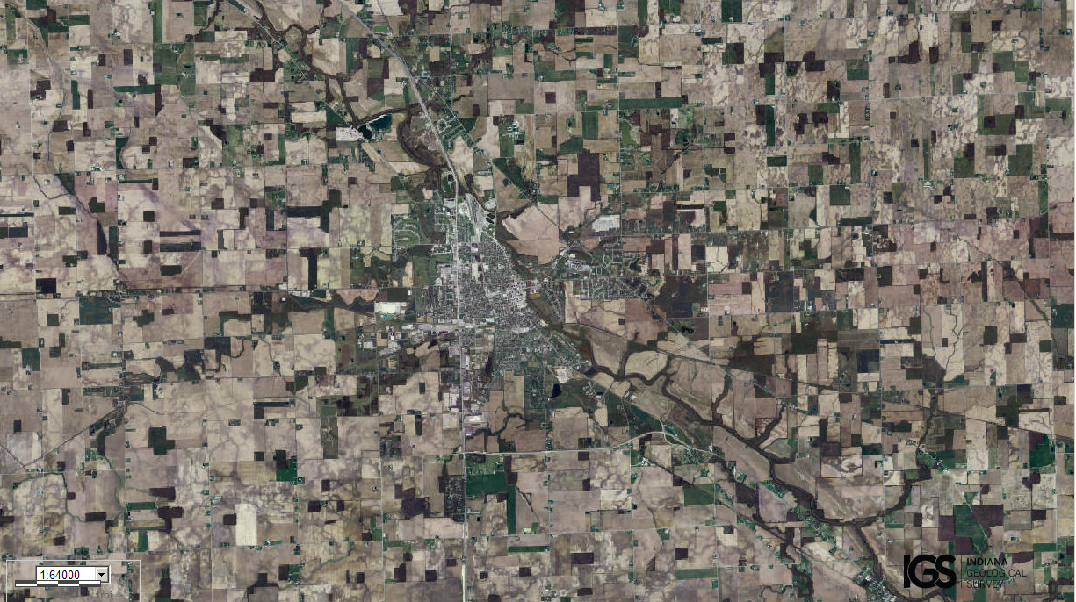
Assets: not too large and not too small, soil for growing food…
Liabilities: lack of enough trees/forests for fuel and hunting…

