Clay City, IN Clay County; Latitude: 39° 16' 36" N, Longitude: -87° 6’ 46” W

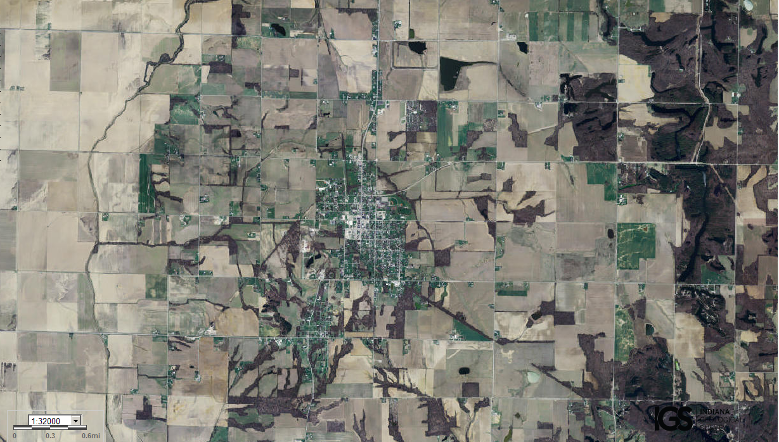
Assets: soils for growing food, flat terrain…
Liabilities: incoming roadways, minimal trees/forests, little hunting…

