Center Point, IN Clay County; Latitude: 39° 25' 1" N, Longitude: -87° 4' 38" W

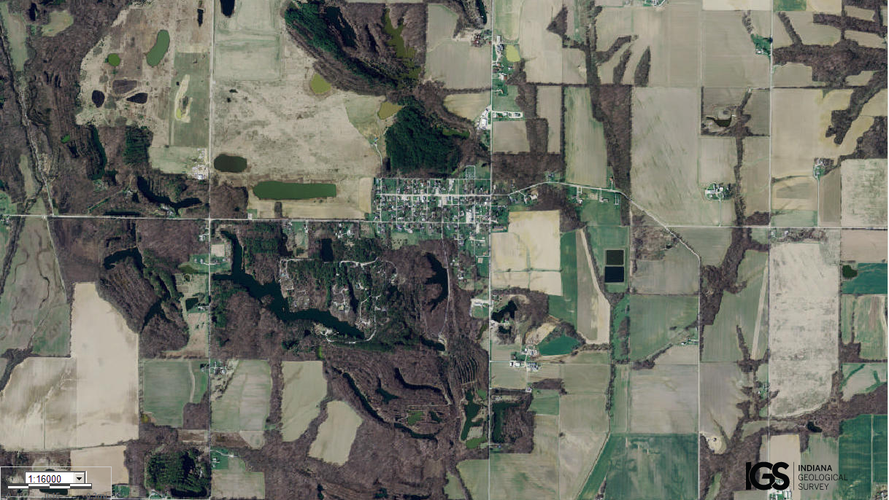
Assets: not too large and not too small, soil for growing food, fresh water…
Liabilities: not enough people to defend…

