Brownsburg, IN Hendricks County; Latitude: 39° 50' 35" N, Longitude: -86° 23' 52" W

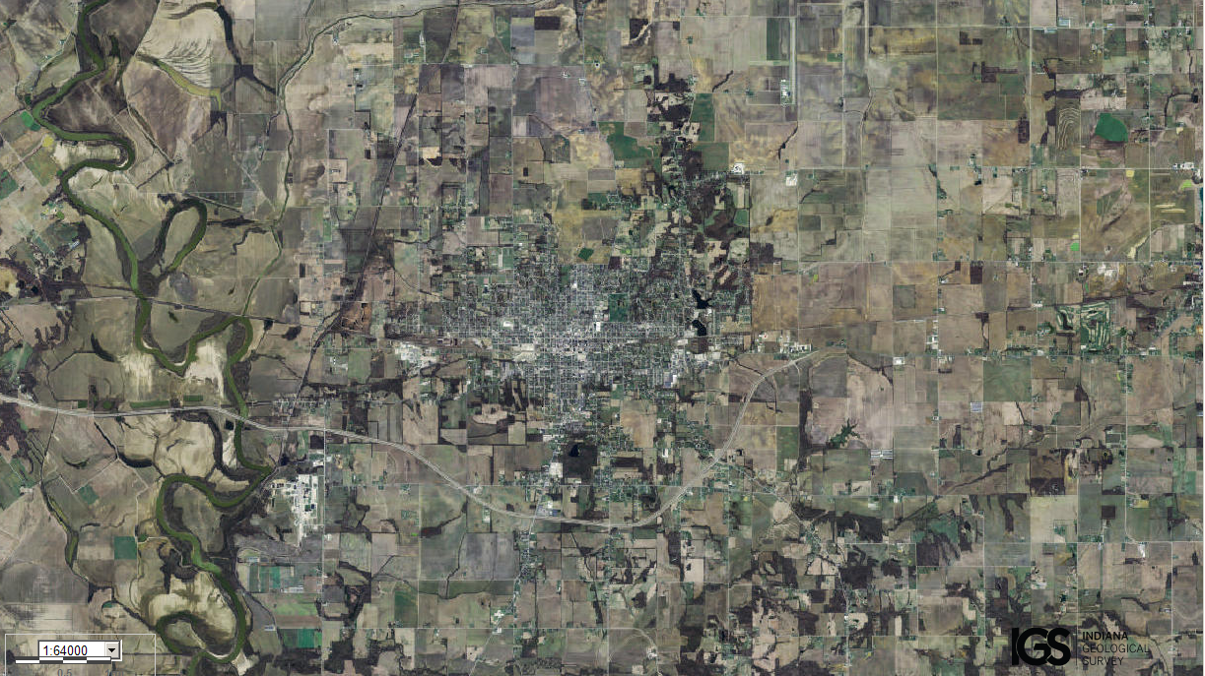
Assets: soil for growing food, fresh water…
Liabilities: too close to Indianapolis, not enough trees/forests…

