Brookville, IN Franklin County; Latitude 39° 25' 23" N, Longitude -85° 0' 46" W 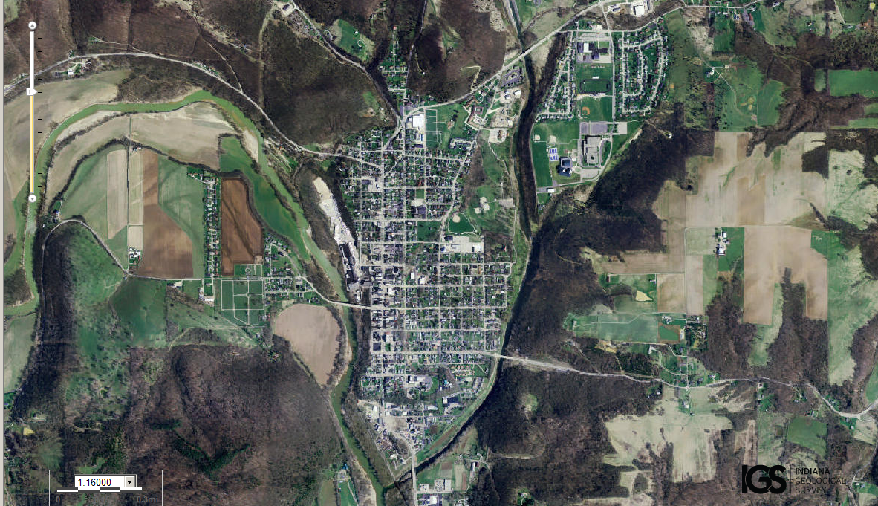

Assets: fresh water, hunting, soil…
Liabilities: trees too close to town, too many roadways in/out…

