Brazil, IN Knox County; Latitude: 39° 31' 25" N, Longitude: -87° 7’ 30” W

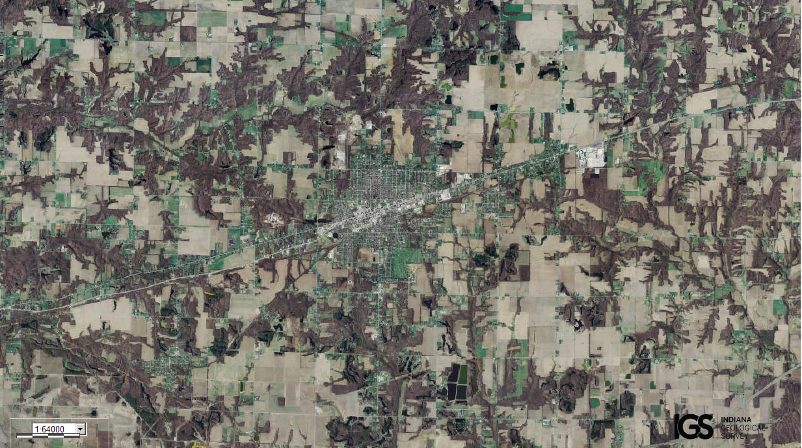
Assets: soils for growing food, relatively flat terrain…
Liabilities: lack of fresh water…

