Amo, IN Hendricks County; Latitude: 39° 41' 17" N, Longitude: -86° 36' 49" W

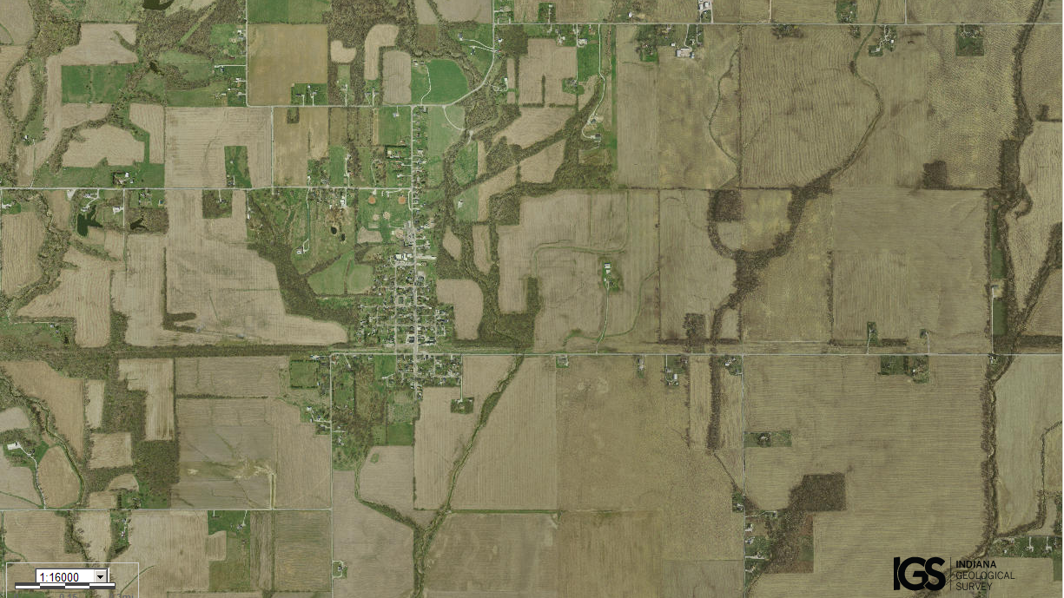
Assets: small area to defend, soil for growing food…
Liabilities: not enough people…

