SLED TEACHER REFLECTION HUB SUBMISSION

There are three parts to this reflection submission. The first part requires a brief description of your instructional activities over the course of a SLED design task. The second part includes your reflection on a student who performed well and your reflection on a student who performed unsatisfactorily. The last section includes your response to two short questions.

Save your file as: Reflection_YourName_YourSchool_YourGrade_Date
Example: Reflection_Capobianco_Purdue_Grade4_11-15-14

When uploading to the hub, use the title: Teacher Reflection: Your Name, Activity, Term
Example: Teacher Reflection: Capobianco, Save the Wolf, Fall 2014

Teacher Name: Kara Fletcher

School: Wea Ridge

Grade: 3

Design Task: Bio Inspired Plant

Date: 3-9-15

PART I: Overview of your SLED lesson(s):

Day | Brief description of lesson activities you enacted each day over the course of the SLED design task | What do you think your students learned each day
1 | Introduce plant vocabulary using a foldable/TPT unit. Cut and place in pocket in notebooks. Complete a KWL chart. Place it in notebook. | Students became familiar with the vocabulary words: flower, cone, seed, nutrient, reproduce, root, stem, leaf, cotton, wool
2 | The students will create a plant foldable to outline the different parts and jobs for the plant structure. | Students will identify the job of the leaf, roots, and facts about plants. They will also closely look at photosynthesis and how plants make their own food. Finally they will learn the plant’s life cycle.
3 | Finish the plant foldable. | (Same as previous day) Students will identify the job of the leaf, roots, and facts about plants. They will also closely look at photosynthesis and how plants make their own food. Finally they will learn the plant’s life cycle.
4 | Flower Dissection Lab Activity | Students will closely at a flower and the stem system after it is dissected. The students will observe the water flow through the plant over the course of 2-3 days.
5 | Guest: Parent Norm Blanchard, Engineer at Valero Ethanol Plant | Norm will speak with the kids on his role as an engineer with the production of corn, as well as the design process involved.
6 | INQUIRY DAY 1: Flowers (page 7 in SLED lesson plan) | Students will observe and fill in chart to rank the materials (coffee filters, paper towel, tissue paper) from least absorbent to most absorbent.
7 | INQUIRY DAY 2: Root System (page 7 in SLED lesson plan) | Students will observe and fill in chart to rank materials (acrylic, cotton, wool string) from least absorbent to most absorbent.
8 | Review design process. Introduce activity: Design Paper Flowers. Use the notebook to record client, user, problem, goal, criteria, and constraint. | The students identified the problem and recorded the information to prepare to develop a plan.
9 | Students created individual and team designs. They listed materials, measurements, labeled parts, and conferenced with teacher. Students then created their bio inspired plant. | Students used their knowledge from the inquiries to design and develop their bio inspired plant.
10 | Reflection & Post Assessment | Students presented their prototypes to the class, sharing what worked and what didn’t work throughout the process. They brainstormed ideas of how they could improve their designs.  Students reflected on their prototype’s performances and challenges that they faced.

Please answer the questions below:

1. What worked well?

- Prior Experience: As the third design task, students were very excited and familiar with the process and procedures of the Engineering Design Process. Students were very motivated and worked hard to meet the goal of the task.

- Inquiry: Through the use of inquiry, students were able to experiment with materials to see which type of string and paper would be the most beneficial in carrying and absorbing water. This hands-on approach not only provided students with helpful hints about which materials to use, but they were able to learn and experience making observations about these materials as well.

- Notebooking/Foldables: We used several foldables to introduce the unit and reinforce concepts about plants that the students would later need to know when they went to design their prototypes. Foldables served as a means for students to not only articulate what they had learned, but they could later revisit these notes to recall information that they may need. Some of the most beneficial foldables that we used included the following:
-scientific vocabulary
-diagrams
-tables for inquiry activities
-templates for designs
We also utilized a “foldables checklist” to include as a part of each child’s grade for the unit. This held them accountable for participating in class and better prepared them for implementing the design task.

- Encouraging Teamwork: Students were able to choose their own teams and were held responsible for working together and integrating what they had previously learned in their designs, then later collaborating with a group.

2. What are two ways you can improve your efforts toward integrating design?

- Enhance Inquiry Experiences: The use of inquiry was very beneficial in this design task. I would like to try to incorporate more inquiry throughout each design task. As the teacher I had to lead the class and use inquiry as primarily a presentation due to time constraints. I believe that the use of inquiry could be improved by having the teacher serve as merely a facilitator, where the students would carry out the tests and draw their own conclusions.

- Incorporating Other Subjects: In the future I would like to incorporate other subjects such as reading, social studies, and math in this design task. I would also like to teach this unit in the spring time so we could go outside and even plant flowers to supplement our activity.
PART II: Reflection#1 on student performance:

Include an image of work from one student who you thought performed well on the task. Insert the image here within the Word document. This image may be a copy of the student’s notebook entry(s) or an image of the team’s artifact or an actual picture of the student at work.

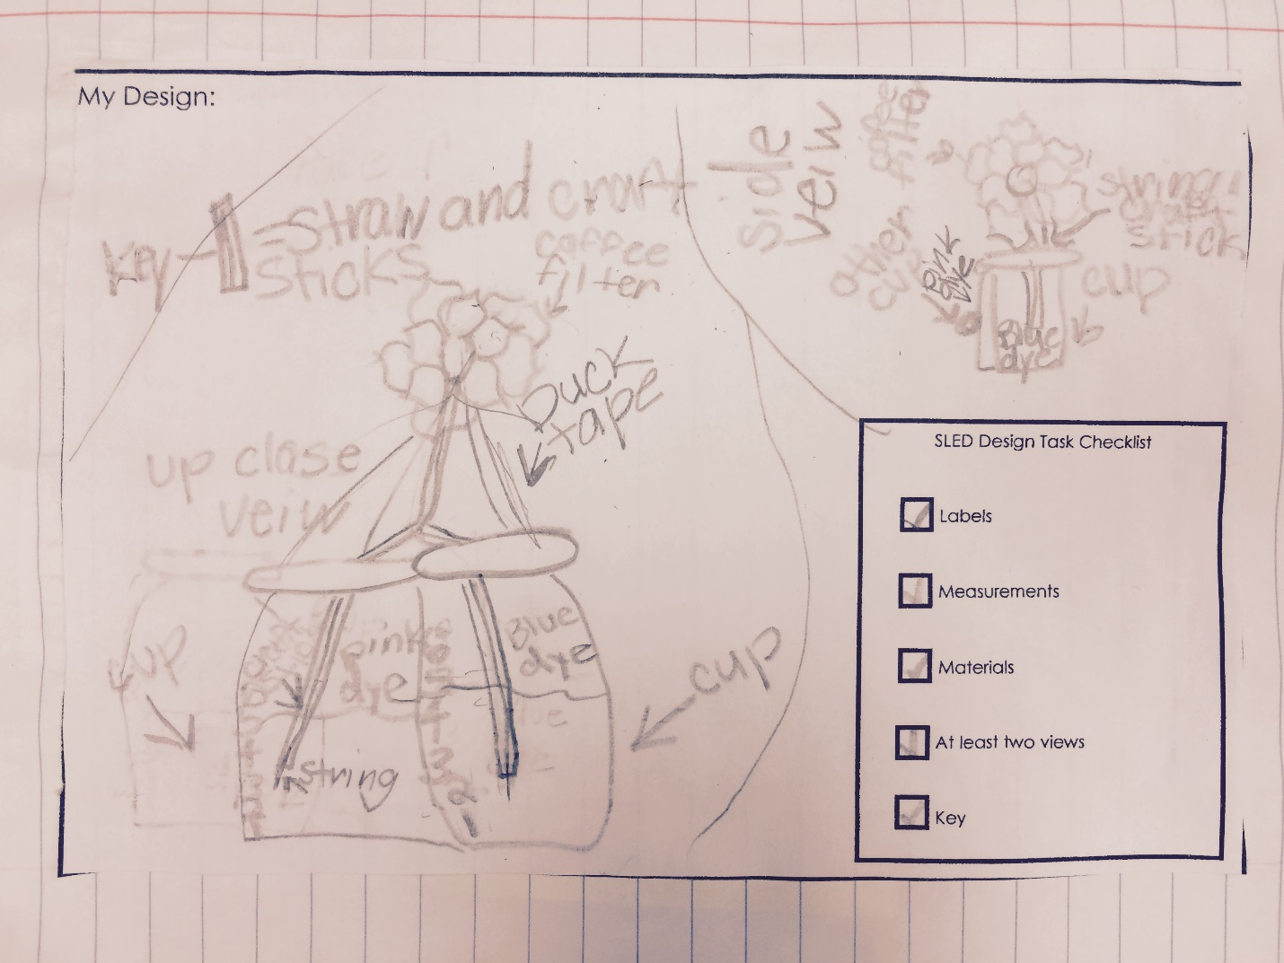

In the space below describe what the image(s) is about and why you would explain or characterize the student’s performance as mastery or excellent.

This particular student performed very well throughout the design process, especially while designing/sketching. Prior to beginning this unit we had a lesson from Todd Kelly on sketching. He discussed using labels, measurements, and various other details while sketching. He also talked about other inventors and scientists such as Thomas Edison and shared examples of his sketches. This proved to be very beneficial when it came to designing and sketching in our class.

This student used several details such as measurements, labeling of materials, and even utilized a key. Her drawing and use of two colors of dye and attention to detail helped her achieve success on this task.
Reflection#2 on student performance:

Include an image of work from one student who you thought did not perform as well (unsatisfactory) on the task. Insert the image here within the Word document. This image may be a copy of the student’s notebook entry(s) or an image of the team’s artifact or an actual picture of the student at work.

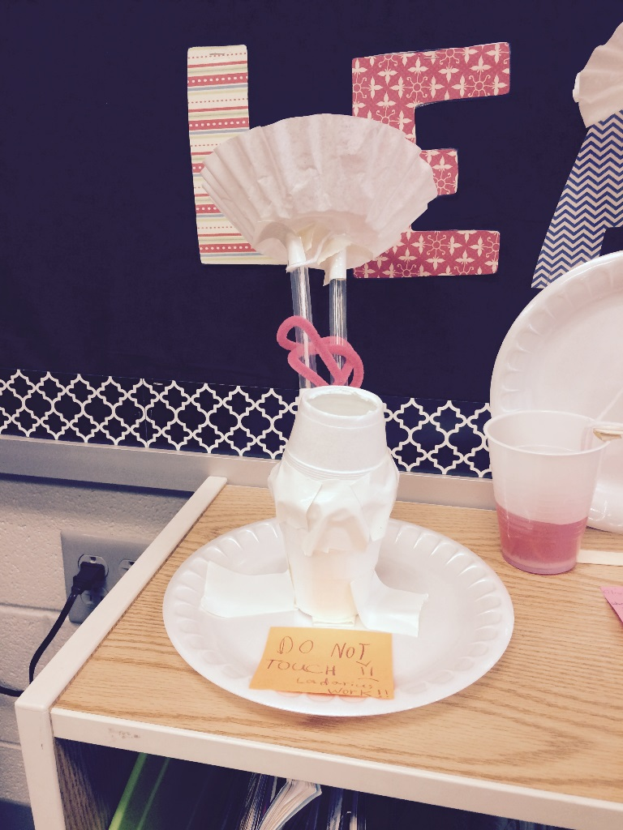

In the space below describe what the image is about and why you would explain or characterize the student’s performance as unsatisfactory.

This particular student refused to work with a group. After beginning the task on his own, it was clear that his ideas were missing a few key components in order to make the paper flowers “tye-dyed”. Unlike the rest of the class, this student only used one cup with one color of food coloring, therefore making it impossible for the flower to turn more than one color.

Unfortunately with all of the prototypes the string proved successful in carrying the water/food coloring up the “stem” but it was never able to reach the paper/flower petal to be absorbed by it.

PART II: Reflection #3
Describe one thing you enjoyed about instructing this SLED task.

My favorite thing about this SLED task was seeing the immediate transfer from my teaching, directly to the work of my students. In a typical science lesson, students may read and even study a term such as capillary action but it is almost guaranteed to be instantly forgotten. During this lesson, students clearly showed that they understood the concept, even though they may have forgotten the terminology at times. I believe that this is the definition of meaningful learning!

Describe one thing in your practice you would improve upon next time you implement this engineering design task or another SLED design task.

One thing I would like to improve is enhancing the inquiry activity, especially the one where the string was tested. While students learned how the liquid traveled up the string, I would like to add another variable such as the quantity of string used. Several of my students were able to make very good prototypes, but unfortunately the water was never able to travel/absorb all the way onto the paper/flower petal. I would like to expose my students to more varieties to try in hopes of achieving more success with the end goal in the future.

