Grade Level:  4rd Grade | Total Time Required:  ~ 3 – 5 class sessions (30 minute each)
Prepared By: Venkatesh Merwade, Brad Harriger, David Eichinger, and Erin Doherty

Lesson Objectives:

In this lesson, Students will be able to:

- Explain how electricity flows through a circuit.
- Explain how different materials affect the flow of electricity in a circuit.
- Design a circuit that will activate a door alarm when it is opened.
- Evaluate their team’s results and present their findings to the class.
- Learn about and apply the principles of the engineering design process.
Indiana Standards:

Content Specific:
- Science 4.1.3 (Physical Science)
Construct a complete circuit through which an electrical current can pass as evidenced by the lighting of a bulb or ringing of a bell.

Common Core Mathematics:

Common Core English and Language Arts:

Concepts and Vocabulary

Science Concepts / Vocabulary:

Term | Defined by an engineer or scientist | Defined by a 4th grade student
Electricity | - Fundamental property of matter caused by the presence and motion of electrons, protons, or positrons, manifesting itself as attraction, repulsion, luminous and heating effects, and the like.  - a fundamental form of energy observable in positive and negative forms that occurs naturally (as in lightning) or is produced (as in a generator) and that is expressed in terms of the movement and interaction of electrons.  - The science dealing with electric charges and current | - Energy that comes from the wall socket used to power lights, radios, appliances, etc.
Electronics | - The science and technology concerned with the development, behavior and applications of electronic devices and circuits | - Technology used to make electric devices.
Electric Current | - Movement or flow of electrically charged particles, typically measured in amperes.  - A flow of electrons in an electrical conductor. | - Movement of electric energy through a wire.
Battery | - A combination of two or more chemical cells connected together electronically to produce electrical energy. | - A cylindrical device that holds electric energy that is used to power games, flashlights, and ipods.
Resistance | - The opposition to current flow. | - Blocking the movement of electric energy through a wire.
Circuit | - A conductor or a system of conductors through which electric current flows. | - A pathway to allow electricity to flow through electronic devices that typically leads to something useful like a sound, or a light.
Load | - The amount of electric power delivered or required at any specific point or points on a system. The requirement originates at the energy-consuming equipment of the consumers.² | - The electric powered object to be powered.
Watt | - The electrical unit of power. | - The electrical unit of power.
AC (Alternating Current) | - An electric current that reverses direction at regular intervals. | - When the movement of electric energy in a wire moves in one direction for a period of time and then reverses and moves in the other direction for a period of time and keeps repeating.
DC (Direct Current) | - Electric current in which electrons flow in one direction only. | - Movement of electric energy in a wire that only moves in one direction.
Conductor | - Conductors are materials that permit electrons to flow freely from atom to atom and molecule to molecule. An object made of a conducting material will permit charge to be transferred across the entire surface of the object. | - Things that will let electricity flow through them. Examples include most metallic objects.
Insulator | - Insulators are materials that impede the free flow of electrons from atom to atom and molecule to molecule. If charge is transferred to an insulator at a given location, the excess charge will remain at the initial location of charging. | - Things that will not let the electric current flow through them. Examples include rubber, plastic and wooden objects.

Equipment, Materials, and Tools

List the quantities of all materials and equipment needed:

Materials for a class of 20 students with 4 in each team .

Tools/Equipment | Materials
Safety scissors | Buzzers | Masking tape
 | Wire | Scotch tape
 | 1.5 V batteries | Books/Boxes (for door)
 | Aluminum foil | Small bulbs
 | Duct tape | Paper clips
 | Electrical tape | Marbles or pearls
 | Popsicle sticks

Safety Guidelines:

When lighting small bulbs using a battery and wires, avoid touching the live wire.

Science Content – Basics

What is electricity and electric current?

Electricity is a form of energy produced by the movement of electrons from atom to atom. Electrons tend to stay put in their orbits (or "shells") as long as the atom has the same number of positively charged protons and negatively charged electrons. When something upsets this balance, electrons leave their orbits and become "free electrons." An unbalanced condition can be caused by static electricity, by a magnetic field, or by a chemical reaction, such as in a dry cell battery.
Free electrons are attracted to atoms that have an electron missing. When these leaps occur repeatedly, the electrons move in a stream, a river of electrical energy that we call "current," as if it were made of water.
An electrical current is the flow of electricity through a conductor--a substance like copper wire that transfers electrons easily from atom to atom. The force needed to make the electrons flow is measured in units called volts. The amount of current actually flowing is measured in units called amperes (amps). Considered together, volts and amps determine how much work an electric current can do. The product of volts and amps is called power. Power is measured in watts.

Where does electricity come from?
Power plants make electricity out of other forms of energy. Most electricity in the U.S. today comes from converting the heat energy released from burning fossil fuels--coal, natural gas and oil. The rest is generated from nuclear reactors and from renewable sources, such as sunlight, wind, falling water and geothermal heat.
In a typical power plant, a primary energy source like coal is burned to create heat, which is converted in a boiler to mechanical energy in the form of superheated, high-pressure steam. The steam is directed into a turbine, where it pushes on blades attached to a central shaft or rotor. The rapidly spinning rotor powers a generator.

What is an electric circuit?

An electrical circuit is a path which electrons from a voltage or current source flow. Electric current flows in a closed path called an electric circuit. The point where those electrons enter an electrical circuit is called the "source" of electrons. The point where the electrons leave an electrical circuit is called the "return" or "earth ground". The exit point is called the "return" because electrons always end up at the source when they complete the path of an electrical circuit. The part of an electrical circuit that is between the electrons' starting point and the point where they return to the source is called an electrical circuit's "load". The figure below shows examples of closed and open circuits including source and load.

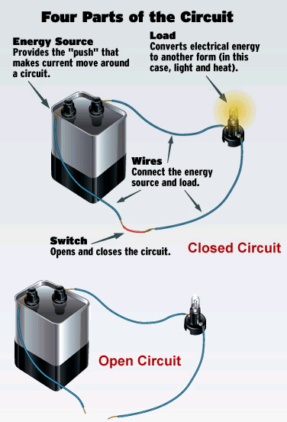

The above circuits can be described by using circuit diagrams as shown below.

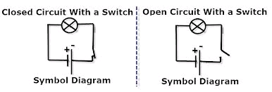

What is electricity used for?

Electricity is an essential part of modern life. In our homes we use it for lighting, running appliances and electronics, and often for heating and cooling. The figure below shows how electricity used in American homes in 2011.
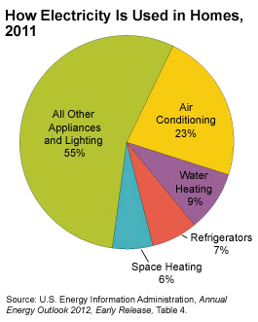

How is electricity stored?

Technically, you cannot store electricity. Electricity is the movement of electrons. When these electrons are sitting in place they are not performing work. In the case of chemical energy (i.e. batteries) no work is being performed. Therefore, you are not storing electricity but you are storing potential energy or potential work. In the case of a capacitor these electrons build up a charge and you are storing their charge but electricity is not being stored. So for practical purposes, one can say that electricity in relatively small amounts can be stored in batteries and capacitors for a time.

For large scale operations such as power plants, several methods are used to store the potential. The most commonly used method is Pumped-storage hydroelectricity (PSH). PSH is a type of hydroelectric power generation used by some power plants for load balancing. The method stores energy in the form of potential energy of water, pumped from a lower elevation reservoir to a higher elevation. Low-cost off-peak electric power is used to run the pumps. During periods of high electrical demand, the stored water is released through turbines to produce electric power. Although the losses of the pumping process makes the plant a net consumer of energy overall, the system increases revenue by selling more electricity during periods of peak demand, when electricity prices are highest.

Sources:

http://www.energyeducation.tx.gov/energy/section_3/topics/what_is_electricity/index.html

http://www.eia.gov/energyexplained/index.cfm?page=electricity_use

http://www.physicsclassroom.com/Class/circuits/u9l4a.cfm

http://en.wikipedia.org/wiki/Grid_energy_storage
Engineering Design

Synopsis of the Design Activity:

Goal: To design a door alarm to let you know when uninvited people sneak into your room

Who is the client: Self (You!)

What is the design: A door alarm

Criteria (list):

(i) The door alarm should sound after the door is opened and turn off after the door is closed

(ii) The alarm should sound even if the door is slightly opened

Constraints (list):

- Only available material should be used
- Door does not have a lock
- Door can only open in one side of the room

Lesson Plan #1
Guiding Question – What is an electrical circuit?

Time: 30 minutes
Note: In this lesson the teacher will explain what electric circuits are and discuss circuit diagrams

Procedure:

- Start a whole class discussion focusing around the following key questions:
- What is electricity?
- What is electric current?
- What is electricity used for?
- Where does electricity come from?
- Do you know of any source or sources of electricity?
- What is an electric circuit?
- How is electricity stored?
- What else do you know or want to know about electricity?
Tell students that they cannot see electricity because electrons, the charged particles whose movement through a substance creates electricity, are too small to be seen even with a microscope. When electrons flow through certain substances (like copper wire), they form an electrical current. Electrical current provides energy to power all kinds of things, from video games to refrigerators to cars!
- Teacher will explain the concept of electrical current/electron movement through an act-out¹.
  - Have students get in a circle within arm’s length of each other.
  - Tell students that you (teacher) represent a battery and they represent a wire conductor. The circle represents a circuit. (Note: The word circuit comes from the Latin circuitus, which means "to go around.")
  - Distribute an object -- like a ball, a marble, or an eraser -- to each member of the circle, including yourself. Ideally, everyone should have the same object. Tell students that these objects represent electrons inside a wire conductor. Explain that a wire conductor is full of electrons.
  - Remind students that you are playing the part of the battery in this circuit, and explain that all batteries have a positive end, represented by your left hand, and a negative end, represented by your right hand. Pass your "electron" to the student on your right. The student receiving your electron should in turn pass the one he or she is holding to the right. Have students continue passing on electrons to the person to their right. Tell students that because electrons share the same negative charge, they repel one another, which keeps them moving along in the same direction. State again that the flow of electrons through a conductor is called electrical current.
  - Tell students that as long as the circle remains intact and the electrons continue to flow, their circuit is closed. To illustrate what happens when a circuit breaks, or pens, create a gap in the circle of students that is too wide across to pass electrons. The current will stop as a result.

Download the following video/animation, and then show it to students to demonstrate how electrons flow in a circuit and how/why a light bulb gives off light.

http://archive.tlt.psu.edu/mto/energy/bulbs.html

After the act-out, explain the same concept of circuit diagram. The technical way of drawing a circuit diagram is shown below using a switch. Operating the switch will either close the circuit to let the electrons flow from battery to the light bulb (light bulb will turn on), or break the circuit to stop the flow of electrons (light bulb will turn off).

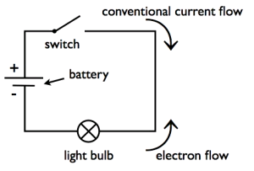

¹ http://www.teachersdomain.org/resource/phy03.sci.phys.mfe.lp_electric/

Fourth graders, however, will have difficulty understanding the symbols and nomenclature of correct circuit diagram. It may be easier to explain them by using a hybrid approach that includes the circuit and symbols that they understand. The following figures show some examples.

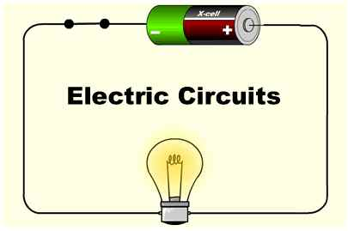 | 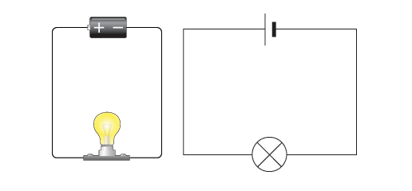
http://monstersciences.com/blog/?p=285 | http://www.bbc.co.uk/bitesize/ks3/science/

Lesson Plan #2
Guiding Question – How does one create a simple circuit?

Time: one 30 minute class session

Procedure:

- Divide the class into groups of four or five students

- Explain to students that they will be testing different connection combinations (or creating a circuit) with two pieces of wire, a light bulb, and a battery.

- Explain how an electric bulb works by using the diagram below

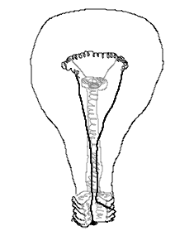
Filament
Bulb
When electric current flows through the filament made up of tungsten, it heats up emitting visible light. The above image shows a commonly used electric bulb. The entire assembly is housed in an envelope of glass. The shape of the glass is responsible for giving directionality to the light.

- Next, give one 1.5V AA battery, one small bulb and two wires to each group, and have them figure out how to light the bulb using the material provided

- Have students test multiple ways of lighting the bulb with one wire and two wires. After allowing students to experiment with the materials for a while, ask them to draw two examples of ways that would create a working circuit and two ways that do not create a working circuit.

- Lead a teacher discussion about experimentations
  - Why do you think your examples worked?
  - Have students share their “circuit” designs.
  - What are the key elements of a working circuit?
  - Contrast Open and Closed Circuits

- Use worksheet (Appendix) for students and have them make prediction for each hookup or circuit provided in the worksheet. Then have them confirm their prediction by creating the exact hookup using the material given to them.

- Once all students have finished with their experiments, ask them to reflect on why they believe some combinations worked, while the others did not.

Lesson Plan #3
Guiding Question – How to design a door alarm with a simple circuit?

Time: one 60 minute class session or two 30 minute class sessions

Procedure:

- Describe the design challenge to the students: “Someone has been sneaking into our classroom when the class has been at art. Your teacher needs help in designing an electric door alarm prototype with an open and closed circuit. This alarm should make sound when the door is opened and will turn off when the door is closed.”
- What is the design challenge or problem?
- Who is the client?
- Criteria?
- Constraints?

- In the previous lesson plan, the students have learned about open and closed circuits. The alarm will only sound when the door is opened, which means the circuit is closed. The circuit that the students will design opens when the door is closed, and vice versa. This is a relatively difficult concept to grasp. Therefore, before getting into the actual design, it is better to go over some basics of door operation with students so they can get some clues on how to best handle the design problem. This can be done by using the door of the classroom to show them that the door is hinged on one side, and there is a gap that opens and closes when the door is opened and closed. Similarly, as the door is opened, the gap between the door and the wall also closes. When the door opens, the bottom of the door is touching the floor in the room, etc.

- Describe the list of materials available to them. Briefly explain how a book cover will be used as the door for which the students will design the door alarm.

- Divide the class into groups of four, and ask each group to gather the material needed to design the door alarm (buzzer, one battery pack, book/box, wires, and any other material they think is needed)

- Have students in each group discuss how they will incorporate the concept of an open and closed circuit in their design.

- Have each group draw a design of their prototype illustrating the material used and how they will close the circuit to cause the alarm to sound.

- Ask them to indicate all the materials they will be using on the circuit diagram.

- After their circuit diagram is complete, have them present their design to the class.

- Build the circuit based on their design, and demonstrate the door alarm to the class.

Assessment/Wrap-up Discussion

- What have you learned from this lesson about circuits that you did not know before?
- What parts did they use as conductors? Why?
- In what order did you connect the parts? Is it necessary to connect the parts in a particular sequence?
- How do you know that the electricity is flowing?
- Can you trace the path of electrons in your circuit?
- What can cause your circuit to break? What will you do to fix it?
- How can your design be improved?
- Can this circuit be used for another application besides a door alarm? How would you modify the circuit for another application?

Lesson Extensions and Resources

Design Activity
Student Resource

Designing a Door Alarm

Someone has been sneaking into your classroom when the class has been at art. Your teacher needs help in designing an electric door alarm prototype with an open and closed circuit. This alarm should make noise when the door is opened and will turn off when the door is closed.

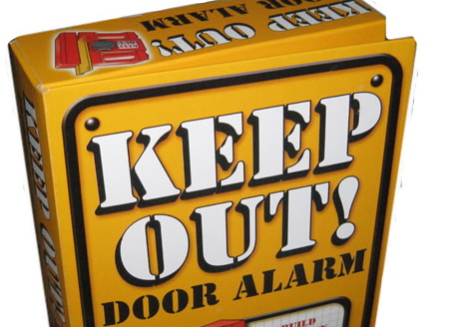

Criteria

- The door alarm should ring when the door is opened
- The door alarm should turn off after the door is closed
- The alarm should sound even if the door is slightly opened

Constraints

- Only use materials provided.
- There is no lock on the door
- The door opens on only one side in the room

Appendix

