Name___________________________

Date____________________________

**Water Filtration Design Packet**

Your job is to design a water filter that will make dirty water as clear as possible. When you design your water filter, you will have a two-liter bottle, rocks, sand, coffee filters, cotton balls, and a few other materials to create your filter. Most importantly, think about what order you put the materials in the bottle and how the materials will filter your water. **Design** your water filter in the space below and label the materials needed. (10 points)

Top of bottle

**Explain** your design and why you think it will work well to filter the water. (5 sentences needed, 10 points)

_______________________________________________________________________________________________________________________________________________________________________________________________________________________________________________________________________________________________________________________________________________________________________________________________________________________________________________________________________________________________________________________________________________________________________________________________________________________________________________________________________________________________

As a **design team** discuss strengths and weaknesses of all the design on your team. Below list three things you learned about other students designs. (6 points)

1.________________________________________________________________________________________________________________________

2.________________________________________________________________________________________________________________________

3. ___________________________________________________________

_____________________________________________________________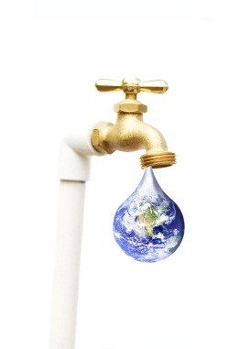

The next step is to create a **redesign** that combines many of your group ideas together. Everyone in your groups needs to create a new design together, sketch and label the design below. (10 points)

Explain your redesign and why you think it will work well. (4 points)

_______________________________________________________________________________________________________________________________________________________________________________________

After you created your filter, what work well and what would you like to improve? What could have made your water filter better? (4 points)

______________________________________________________________________________________________________________________________________________________________________________________________________________________________________________________________________________________________________________________________________________________________________________

Grade your group members (A, B, C, D, F) on effort and teamwork. Explain why you gave the members their letter grade

1. ________________________________________________________________________________________________________________
2. ________________________________________________________________________________________________________________
3. ________________________________________________________________________________________________________________
4. ________________________________________________________________________________________________________________
5. ________________________________________________________________________________________________________________
6. ________________________________________________________________________________________________________________