IMPACT FLC
Spring 2022 Semester
Evaluation Report
Instruction Matters:
Purdue Academic Course Transformation

(9/30/2022)
Prepared by:
The Evaluation and Learning Research Center

Executive Summary
Instruction Matters: Purdue Academic Course Transformation (IMPACT) is a semester-long, faculty development program that aims to educate instructors about research-based teaching practices that enhance their ability to create student-centered learning environments. The Evaluation and Learning Research Center (ELRC) has served on the IMPACT evaluation team since the program’s inception; developing and leading the evaluation of faculty development outcomes from the professional development experiences offered. This report describes the findings of our evaluation of the spring 2022 faculty learning community; this evaluation used surveys and focus group interviews to collect information on the experiences, perceptions, and development outcomes for participating instructors. Overall, we find that faculty fellows are satisfied with the materials and resources provided by the program, which have enhanced their ability to implement student-centered pedagogy. Fellows are inspired to try new approaches to student engagement and motivation and are connected with peers and support staff in pursuing their teaching scholarship. Moreover, participants suggest that the program could extend its resources to sustain a community of practice among graduates and support staff for continued development, feedback, and accountability. Fellows are keen on refining their practice and methods to reflect their teaching styles in the pursuit of their own satisfaction and success.

Key Findings
- Fellows gained an appreciation for structured course design; as well as, new knowledge and vocabulary to conceptualize and communicate their teaching goals and strategies.
- FLC participants gained motivation to engage in the hard work of reflection and course design/redesign, as well as, appreciation for the necessity of questioning assumptions about how to engage students.
- After participating in the FLC, IMPACT fellows had enhanced sense of their own self-efficacy for student-centered pedagogy.
- IMPACT Fellows gained confidence in their plans through the expert feedback of IMPACT faculty and staff mentors; this available expertise helped them move from concepts to tactical strategies.
- FLC participants appreciated the structured time and accountability provided by collaborative relationships with their peers and the IMPACT staff.
- IMPACT Fellows felt that IMPACT was efficiently designed but had additional resources available for those who wanted to go deeper on any subject.
- Fellows plan to implement course changes that are designed to enhance student engagement by strengthening student feelings of relatedness, competence, and autonomy (the basic psychological needs).
- After participating it the IMPACT FLC, fellows were less concerned about external barriers (real or perceived) that may limit the successful implementation of their redesigned course.

Evaluation Approach and Findings

Background and Introduction
IMPACT uses a cohort-based model built around a strong faculty learning community (FLC) to promote pedagogical development for student-centered course design. It is a partnership among the Center for Instructional Excellence (CIE), Purdue Online (PO), Purdue University Libraries and School of Information Studies, Institutional Data Analytics and Assessment (IDA+A), and the Evaluation and Learning Research Center (ELRC), with support from the President’s and Provost’s Offices. Staff and faculty from these units work in teams with IMPACT Faculty Fellows to:
- Define an appropriate transformation goal for their particular course that considers content, discipline, course size, faculty preferences, and abilities;
- Reflect on teaching and learning philosophy through time engaged in discussion with peers;
- Identify course-level learning outcomes; and
- Map those learning outcomes to course activities and assessments that enable all students to successfully meet the course goals.
This report is a summary of the evaluation of the Spring 2022 FLC IMPACT program. The ELRC has evaluated all iterations of IMPACT to understand faculty experiences in the professional development program to inform continuous improvement.
The evaluation of the FLC was designed to answer the questions:
Q1: To what extent was the professional development effective in preparing instructors for their instructional redesign projects?
Q2: What are instructor perceptions of the professional development activities and resources?
Q3: What are instructor expectations, plans and goals for implementing their course redesign?

Methods
The ELRC and other members of the IMPACT evaluation team developed surveys to collect information on faculty experiences in the program and monitor the outcomes associated with participation in IMPACT. In spring 2022, 25 instructors participated in the IMPACT FLC; pre- and post-participation surveys comprised primarily of closed-response items were completed by 17 and 19 respondents, respectfully. The post-participation survey also included open-response items, which asked about resources and plans for course implementation, as well as, benefits of participation in IMPACT and suggestions for improving the program. Repeated items were analyzed using Wilcoxon signed-rank to test for significant change from pre to post-participation.
Interview data were collected from 22 fellows across four focus group interviews and one individual interview session. Focus group interviews were recorded and transcribed verbatim for accuracy. Transcriptions were then uploaded to NVivo and coded for descriptive categories and emergent themes in accordance with the evaluation questions. Open-ended responses from the post-participation survey were also included in the qualitative analysis.
The interview protocol was designed for participants to identify and reflect upon:
- lessons learned during the FLC;
- expectations of and feedback on the FLC and associated support activities/meetings/assignments; and
- participants’ expectations and plans for the redesigned course.

Evaluation Findings

Q1: To what extent was the professional development effective in preparing instructors for the instructional redesign projects?
Instructors who participated in IMPACT gained appreciation for the necessity of thoughtful course design that aims to engage and motivate learners; they also gained the knowledge, skills, and confidence to enact their new mindsets and perspectives in the design of their courses. Figure 1 shows an overview of their self assessed gains after participating in the IMPACT FLC. The sections below describe their gains in greater detail using additional survey and focus group interview responses.

Fellows gained an appreciation for structured course design; as well as, new knowledge and vocabulary to conceptualize and communicate their teaching goals and strategies.
Both junior and senior faculty felt that they benefitted from learning about how to make their course design “intentional and purposeful.” Fellows were able to develop a vocabulary for their teaching process that will help them make their goals, plans and actions transparent and accessible to their colleagues and students.
“[IMPACT] helped me to realize the amount of work that needs to go into thinking about a course and the things that you're trying to convey in that course and what you want the students to learn and how you're going to go about teaching it, right? Like you were just said, going from the big picture to the actual what am I going to do? And I think this course has been particularly helpful with that because in my discipline…there's not an emphasis on pedagogy and teaching, so I think having this course really helped me think about how two develop a course and the activities for teaching…” FLC Participant

“I've learned how to articulate what we're trying to do and I think that's a big takeaway for me, is kind of just being able to put it into words, you know, what my goals are, not just kind of trying to describe a touchy-feely sort of approach but talk about it with the terminology that I learned while I was here in this class…” FLC Participant

Figure 1. IMPACT Fellows strongly agreed that they gained new ideas, skills and perspectives from their participation in the IMPACT FLC.

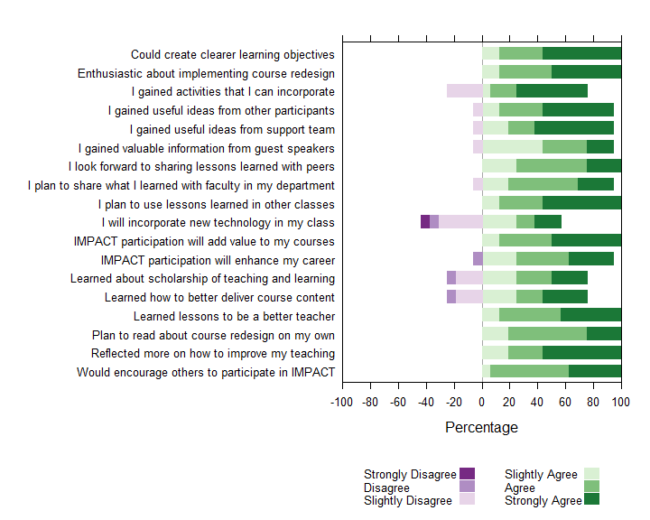

FLC participants gained motivation to engage in the hard work of reflection and course design/redesign, as well as, appreciation for the necessity of questioning assumptions about how to engage students.
IMPACT created space for fellows to interact with colleagues with a shared investment in teaching, which fostered a safe community to question old assumptions or break old habits of mind. Fellows mentioned that they came away with an openness to new ideas and new strategies. The community encouraged them to reconsider their ideas about students, teaching and learning that may be too narrow or based on limited personal experience.
“I have loved having time each week that I get to set aside for reflection and collaboration with colleagues. Knowing that time is coming has forced me to make some decisions and pursue some actions that might have only stayed as ideas otherwise.” FLC participant
“one thing I've gotten is…don't limit yourself. I teach a writing class and I was just thinking, okay, all of my assessments have to be writing assignments, and then being pushed to think but could you offer something else or could you think about this in a different way I think was really important. And then also that equity piece and thinking about what kinds of policies could I implement in my class to create more equitable outcomes…instead of saying, well, you get one chance to submit this essay and that's it…just being open to that possibility and asking but why not?” FLC Participant

“And I realized that I wasn't trying to serve and support every single student in the classroom…there were students who didn't stay as engaged, as motivated, and I kind of gave up on them…But then participating in the workshop really challenged me with my mindset of that. It's like even those students, there's something that I can do to make them care more about the class and feel more motivated to do well. FLC participant

I think one thing that was addressed early that I'd never thought about before is concerning what assets the students bring to the course…they bring life experiences that are probably related to the subject matter that probably never – that I never thought about trying to assess and taking that into account…why haven't I thought about that? Or why haven't heard anybody else talk about it that way? FLC participant

After participating in the FLC, IMPACT fellows had enhanced sense of their own self-efficacy for student-centered pedagogy.
The pre-post FLC survey results for the self-efficacy for student-centered pedagogy scale suggests that participants gained significant increases in three aspects of self-efficacy for student-centered pedagogy: 1) confidence in ability to adapt teaching to student needs and prior experience; 2) confidence in ability to create a learning environment that enhances student knowledge of the course material; and 3) the ability to create a learning environment that enhances student engagement with the course. Figure 2 displays the pre and post mean scores for each item in the scale; Table 1 displays key descriptive information for each item along with p-values for significance testing with Wilcoxon signed-rank test.

Figure 2: Instructor self-efficacy for student-centered pedagogy is higher after participating in the IMPACT FLC.
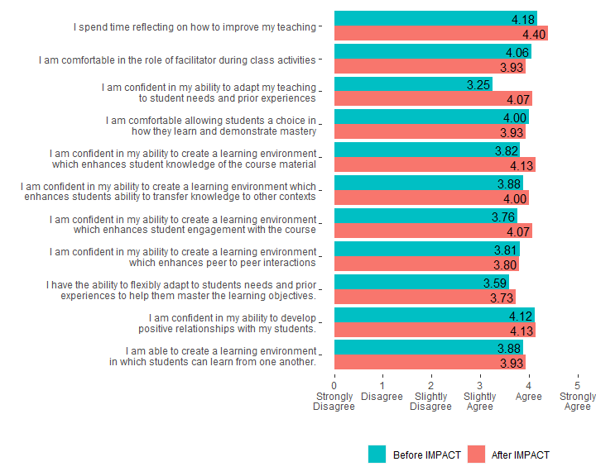

Table 1: Instructor self-efficacy for student-centered pedagogy is higher after participating in the IMPACT FLC.
Item | N | Pre-Mean | Post- Mean | Mean Difference | Pre SD | Post SD | p-value
I spend time reflecting on how to improve my teaching | 16 | 4.18 | 4.40 | 0.22 | 0.95 | 0.51 | 0.0588
I am comfortable in the role of facilitator during class activities | 16 | 4.06 | 3.93 | -0.13 | 1.03 | 1.03 | 0.3173
I am confident in my ability to adapt my teaching to student needs and prior experiences | 16 | 3.25 | 4.07 | 0.82 | 1.24 | 0.70 | 0.0272
I am comfortable allowing students a choice in how they learn and demonstrate mastery | 16 | 4.00 | 3.93 | -0.07 | 0.79 | 0.80 | 0.6547
I am confident in my ability to create a learning environment which enhances student knowledge of the course material | 16 | 3.82 | 4.13 | 0.31 | 1.01 | 0.74 | 0.0047
I am confident in my ability to create a learning environment which enhances students ability to transfer knowledge to other contexts | 16 | 3.88 | 4.00 | 0.12 | 0.78 | 0.65 | 0.1573
I am confident in my ability to create a learning environment which enhances student engagement with the course | 16 | 3.76 | 4.07 | 0.31 | 0.97 | 0.70 | 0.0335
I am confident in my ability to create a learning environment which enhances peer to peer interactions | 16 | 3.81 | 3.80 | -0.01 | 1.11 | 1.15 | 0.2568
I have the ability to flexibly adapt to students needs and prior experiences to help them master the learning objectives | 16 | 3.59 | 3.73 | 0.14 | 1.06 | 0.70 | 0.2059
I am confident in my ability to develop positive relationships with my students | 16 | 4.12 | 4.13 | 0.01 | 0.99 | 0.83 | 0.3173
I am able to create a learning environment in which students can learn from one another | 16 | 3.88 | 3.93 | 0.05 | 1.05 | 0.96 | 0.1797

Q2: What are instructor perceptions of the various professional development events and resources?

IMPACT Fellows gained confidence in their plans through the expert feedback of IMPACT faculty and staff mentors; this available expertise helped them move from concepts to tactical strategies.
Aspects of the IMPACT FLC and fellow’s ratings of their “helpfulness” are shown in Figure 3. The highest valued aspect of IMPACT were mentors and support teams, which were readily available and responsive to the needs of IMPACT fellows. This support allowed fellows to fill in the gaps between ideas and actual classroom strategies. Fellows described mentors as “flexible, they were available, and they cared.”

Figure 3: IMPACT Fellows appreciated learning with and from the IMPACT community; found the structured resources and design process helpful.
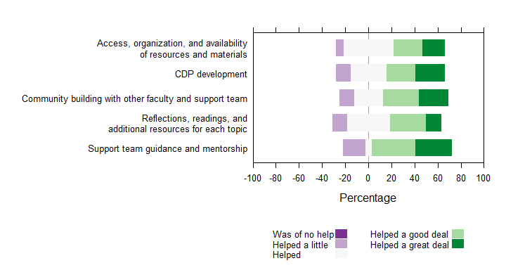

“I'm redesigning a course for a totally new audience…the mentors were fantastic in doing that sit down with your problem and really troubleshoot it and give you lots of ideas about how to take your goals for the course and take what you know about the course and make those two things meet and solve those problems, which is what I had always struggled with.” FLC participant

Participants highly regarded their interactions with mentors during their time in IMPACT, feeling supported as individuals and educators, encouraging them to continue their relationships and instructional growth after completing the program. “I know that the mentors that we have in our particular group would be more than willing to continue to serve as a support moving forward, even outside of this whole IMPACT piece.”

FLC participants appreciated the structured time and accountability provided by collaborative relationships with their peers and the IMPACT staff.
Participants appreciated the opportunity that the FLC provided to devote time and thought to their teaching. Prior experience with or assumptions about R1 institutions had led them to believe that there may not be “an emphasis on pedagogy and teaching” at institutions like Purdue.
“I wanted structured space that would force me to do it, like not all at once… [to} systematically actually sit down and do it.” FLC participant

IMPACT Fellows felt that IMPACT was efficiently designed but had additional resources available for those who wanted to go deeper on any subject.
Focus group participants felt that IMPACT instruction and materials provided ample resources to guide their pedagogical understanding of course redesign. Assigned readings were enough to scaffold discussion, but not overly time intensive. Additional information was available for those who were motivated to learn more.
“I felt like the organizers had done a lot of work to make everything as efficient as possible. It felt like they had really sort of pared down what we were doing to the essence of what we needed to do, which I appreciated. It felt conscientious of my time…there were times when I wanted to follow up on something and they always had additional materials where I could go and look up this source and read more in depth if I felt like it, and so I thought that as great.” FLC participant

Q3: What are faculty expectations, plans and goals for implementing their course redesign?

Fellows plan to implement course changes that are designed to enhance student engagement by strengthening student feelings of relatedness, competence, and autonomy (the basic psychological needs).
In the focus group interviews, instructors described plans to use the concepts of self-determination theory to create opportunities for students to have freedom and choice in how they demonstrate their learning; to interact with peers or even outside communities.
“I came in with a sort of very big goal of making a really big class more engaging. I feel like self-determination theory helped me drill down to like how I would do that, and one piece that I think is important is relatedness... So the team sort of helped me…think through…sending them out into the world to do certain things and relate with people in that way I think was really helpful, and I'm hoping we'll make them more excited about what we're learning.” FLC participant

One person recognized that student choice “can make [them] feel like they’re contributing in their own way, which speaks to autonomy.” Fellows felt empowered to reimagine their approaches, “I shouldn't be afraid to try different approaches…I should challenge the status quo.” Large course sizes were seen as a potential challenge for scaling activities and assessments that promoted autonomy due to the substantial effort to manage new changes. Yet, Instructors received advice and answers to their concerns through group discussion and “working with the support team that helped fulfill some of those goals without making my class a logistical nightmare.”

After participating it the IMPACT FLC, fellows were less concerned about external barriers (real or perceived) that may limit the successful implementation of their redesigned course.
Figure 4 displays respondent agreement with statements regarding potential threats or supports to the successful implementation of their course. Overall, after participating in the FLC, fellows perceived fewer external barriers and more external supports. Table 2 displays additional descriptive statistics for each perceived barrier or support and the results of Wilcoxon signed-rank tests for significance of any change observed. While most items showed improvement (reduced agreement with barriers, increased agreement with supports), fellows’ agreement that their course may need to cover less content increased significantly as did their agreement that students would be receptive to their changes.
Fellows’ effectively reframed their understanding of course content’s role in their class from being “the goal of the course is to cover content” to “the goal of the course is to cover the content that is required for students to achieve learning outcomes.”
“I was preparing the syllabus without thinking a lot about the learning outcomes and objectives. I was, you know, searching around to see…things that are offered in other departments... So yeah, this helps a lot…Instead of thinking the content, I think what I want the students to learn and then move back and revise the content.” FLC participant

Figure 4: Instructors perceive fewer external barriers and more external supports after participating in IMPACT FLC.
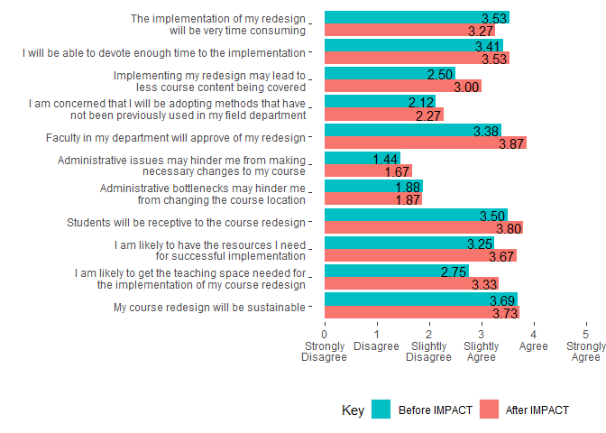

Table 2: Instructors are more confident in that redesigns will be well received by students and colleagues after IMPACT FLC.
Item | N | Pre-Mean | Post- Mean | Mean Difference | Pre SD | Post SD | p-value
The implementation of my redesign will be very time consuming | 16 | 3.53 | 3.27 | -0.26 | 1.37 | 1.33 | 0.5580
I will be able to devote enough time to the implementation | 16 | 3.41 | 3.53 | 0.12 | 0.94 | 0.74 | 0.3173
Implementing my redesign may lead to less course content being covered | 16 | 2.50 | 3.00 | 0.50 | 1.15 | 1.36 | 0.0200
I am concerned that I will be adopting methods that have not been previously used in my field department | 16 | 2.12 | 2.27 | 0.15 | 1.02 | 1.67 | 0.5994
Faculty in my department will approve of my redesign | 16 | 3.38 | 3.87 | 0.49 | 1.36 | 0.74 | 0.1308
Administrative issues may hinder me from making necessary changes to my course | 16 | 1.44 | 1.67 | 0.23 | 1.21 | 1.05 | 0.9416
Administrative bottlenecks may hinder me from changing the course location | 16 | 1.88 | 1.87 | -0.01 | 1.67 | 1.46 | 0.7302
Students will be receptive to the course redesign | 16 | 3.50 | 3.80 | 0.30 | 0.89 | 0.77 | 0.0455
I am likely to have the resources I need for successful implementation | 16 | 3.25 | 3.67 | 0.42 | 1.18 | 0.82 | 0.2342
I am likely to get the teaching space needed for the implementation of my course redesign | 16 | 2.75 | 3.33 | 0.58 | 1.44 | 1.29 | 0.3482
My course redesign will be sustainable | 16 | 3.69 | 3.73 | 0.04 | 0.79 | 0.80 | 0.3657

Conclusion and Recommendations
The IMPACT FLC enhanced fellows’ appreciation of and skills for student-centered course design. Fellows perceived IMPACT to be carefully designed with their interests and needs in mind. Fellows found the community of peers and experts to be highly impactful; the structured space to work in community with others motivated them to broaden their perspectives and transform their course design approaches. The FLC assisted fellows in realistically assessing and planning for the challenges and supports they will encounter as they implement their (re)designed course.
The following suggestions for improving the IMPACT FLC were offered by participants in the survey and focus group interview responses.
- The community formed during the FLC was extraordinarily impactful. Fellows thought that even more effort should be devoted to create community inside the FLC between fellows.
- Fellows desire a structured way to continue their learning and interactions with the IMPACT team around key issues and topics.
  - Fellows suggested IMPACT extensions or optional additions dealing specifically with technology, large courses, or other areas of interest/struggle.
- Fellows desired an advanced FLC that would allow time and structure for a “deeper, higher-level discussion” about teaching philosophies, strategies, and tactics.
- Fellows wanted to be able to track their own and potentially other fellows’ data and results—to have an accountability community that continues for more than a semester.
- Fellows wanted an FLC dedicated to faculty who were practicing SOTL and who would be willing to share and critique their work in community.
- Fellows suggested adding discussion and activities around the human development challenges of teaching—e.g., how to obtain and process feedback, how to meet instructors’ basic psychological needs, and how to develop “sustainable” instruction models and instructors.

