Badge Titles possibilities (Need to show progression)

- Badges
Drop<Ripple<Wave
Pebble<Rock<Gem
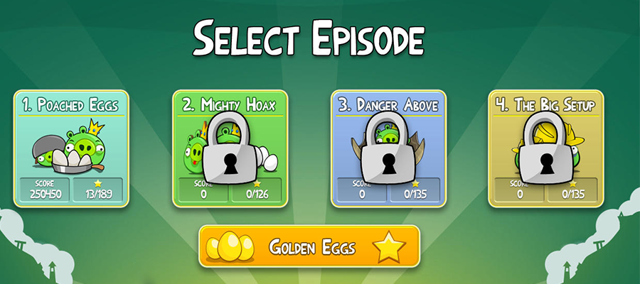

- Physical characters/items/things?
Fill up a fish tank- earn water through time participating (say five logins)
buy supplies/fish through points accumulated
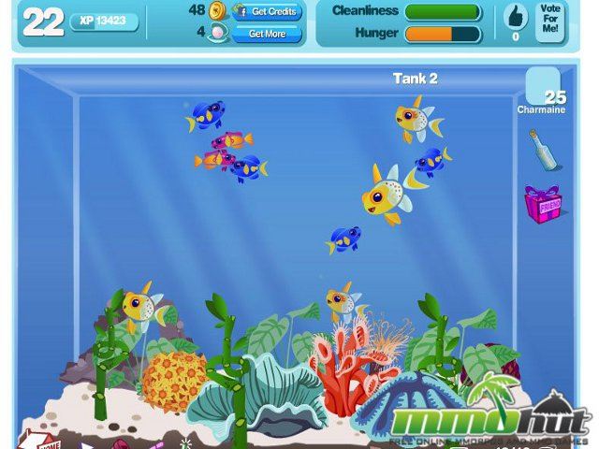
- Creating a path of pebbles to something- have opportunity to unlock different areas

- some kind of intrinsic prize
- levels ranking
- story-driven
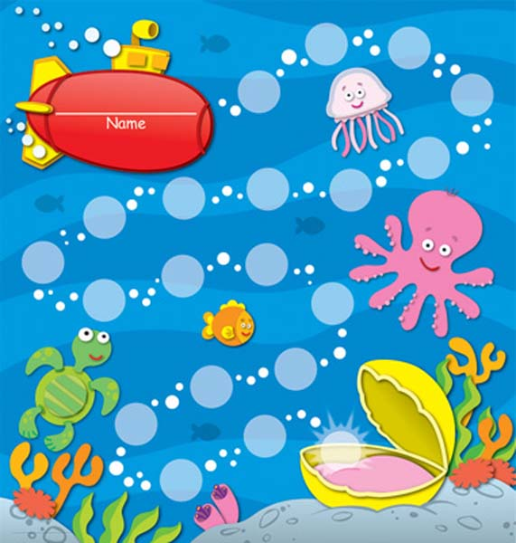

- Measure influence- ripple growing larger/expanding
Interactive social media element allowing users to see other participants and growing influence

New project means new start to new ripple
Visual showing progression
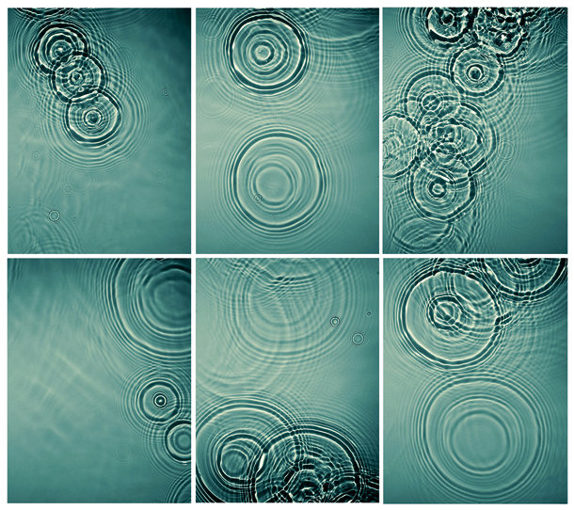

Progression
Shows transparency and gives player meaning in work.
