All about Moraines
- Moraines are formed by glaciers
  - Glaciers- fallen snow that compresses into thick, ice masses that have mobility
- Accumulation of unconsolidated glacial debris as glacier contracts
  - A mound, ridge, or other distinct accumulation of glacial till
- Occur in areas of a past glacial maximum
- Sub-angular/rounded shape
- Unique landscape to define features- debris shaped by trajectory of glacier, leave track behind
- Bands of debris
  - Medial- run down middle of glacier
  - Lateral- run along sides of glacier
  - Terminal- found at ‘snout’ end of a glacier
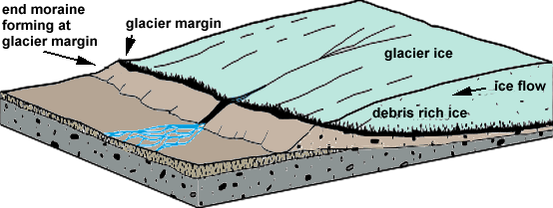
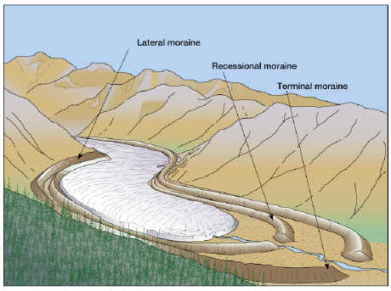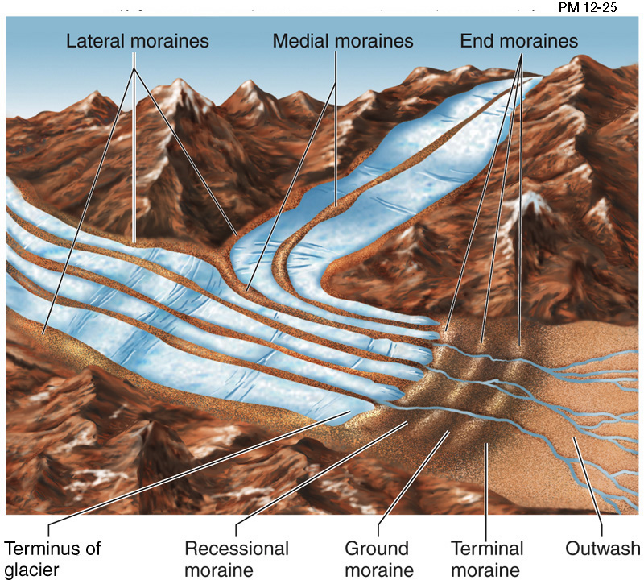
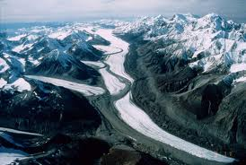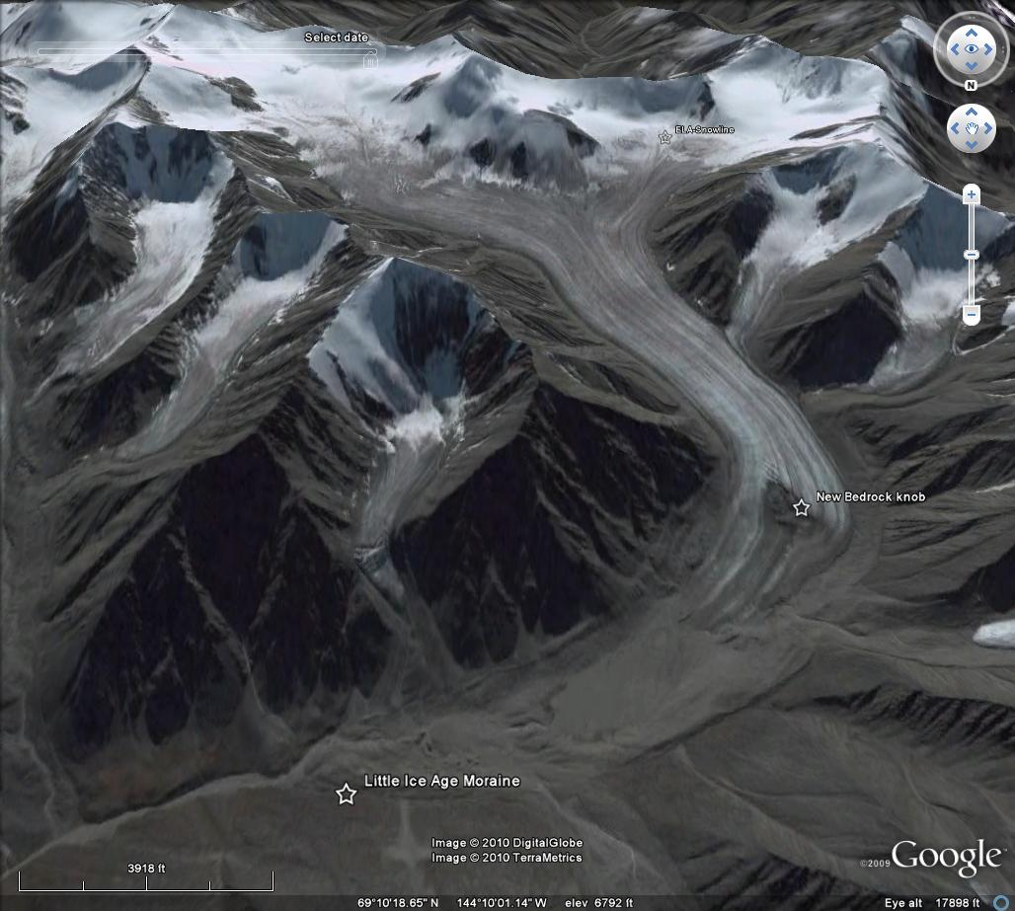
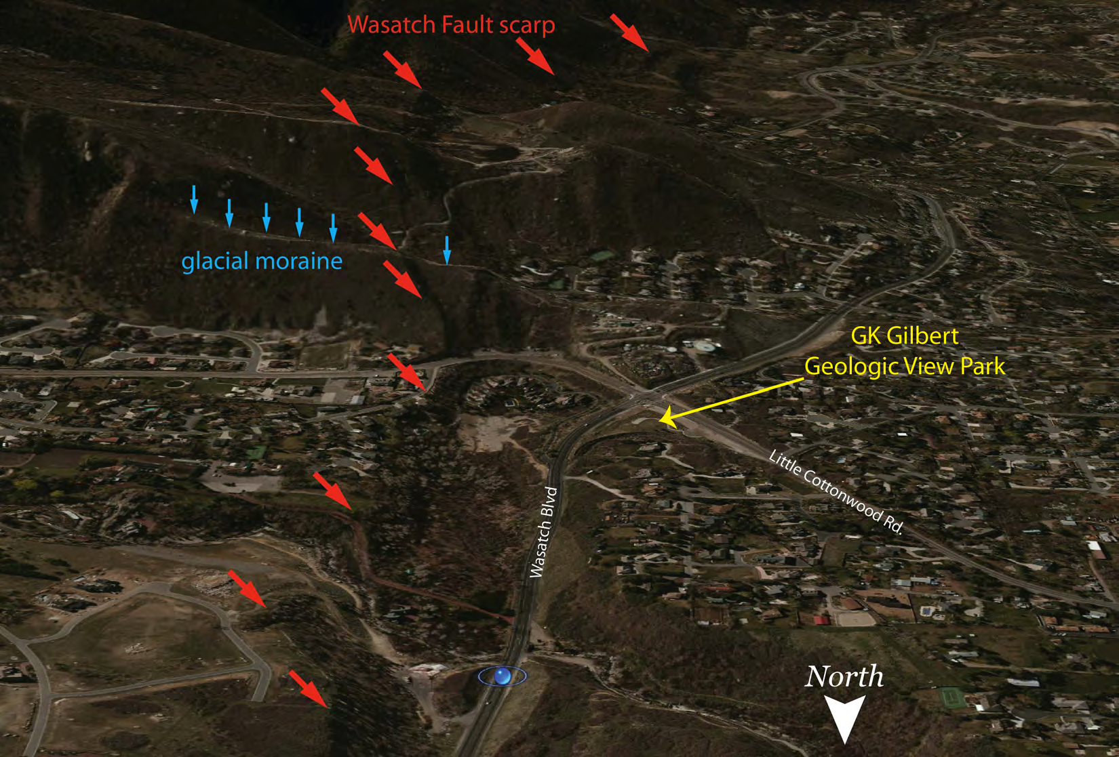
Jon Harbor’s Project
Moraines
Measuring past climate change to look at current climate changes
- Glacier size is one way of doing that
  - getting smaller and as they fall back they leave behind deposits
- Currently mapping Central Asia
Utilize Google Earth to identify moraine areas (place marker on possibilities)
- Include tutorial, “Here’s what we’re looking for”
- Classification put into levels of difficulty
- User given choice of area of interest or be assigned
- Users can help direct where team goes
Project 2: Environment- Rainwater runoff
What was there before?
Observing land use changes over time
Driven by photos, keywords, analyzed by researchers
Storm water management in local community (Purdue-focused)
- Geared toward students on campus (?)
- Observe location, soil type, land use
- SIM City interface (?)

