A Robot Ankle for Amputees
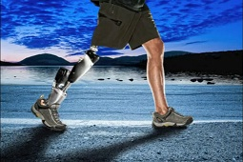
IEEESpectrum, August 30, 2012, Eliza Strickland. ieeespectrum.
A video can be found on EEESpectrum's website for those interested in seeing this technology in action.
Until recently, an artificial leg was an inert object—a clunky piece of wood or plastic that supported a user, but didn’t help much beyond that. But these days artificial limbs can contain advanced sensors and microprocessors, and their motors can provide a power boost for each step.
The BiOM, one of the world’s most advanced ankles, comes from the cutting-edge prosthetics company iWalk. The company was founded by MIT professor Hugh Herr, who directs the biomechatronics group at the MIT Media Lab. Herr is himself a double amputee: As a young man, he lost both legs below the knees after being caught in a blizzard on New Hampshire’s Mount Washington. That accident—and the rudimentary prosthetic legs he was fitted with—convinced him to study biomechanics, and to work on building more advanced prosthetics that mimic the design of the human body.
iWalk has received funding from the U.S. Department of Veterans Affairs and the Department of Defense, and some veterans wounded in Iraq and Afghanistan have already received their bionic ankles. The company has also begun to distribute the BiOM as a commercial product through dozens of advanced prosthetic centers around the country.
IEEE Spectrum visited iWalk’s headquarters in Bedford, Mass., to see its BiOM ankle in action and to learn more about how it works.

