Grade Level:  3rd Grade | Total Time Required:  ~ 4 – 6 class sessions (30 minute each)
Prepared By: Venkatesh Merwade, Brad Harriger, David Eichinger, and Ryan Habben

Lesson Objectives:

In this lesson, Students will be able to:

- Explore how dams work, how they are built, and how they can be used to solve problems in the world.
- Work in teams to design and build an earthen dam using at least two different earth materials so that the dam will hold water for at least five minutes without leaking.
- Evaluate their team’s results and present their findings to the class.
- Learn about and apply the principles of the engineering design process.
Indiana Standards:

Content Specific:
- Science 3.2.6 (Earth Science)
Describe how the properties of earth materials make them useful to humans in different ways. Describe the ways that humans have altered these resources to meet their needs for survival.

- Science 3.4.1 (Science, Engineering and Technology)
Choose and use appropriate tools to estimate and measure length, mass and temperature in SI units.

Common Core Mathematics:

Common Core English and Language Arts:

Concepts and Vocabulary

Science Concepts / Vocabulary:
Term | Defined by a scientist or engineer | Defined by a 3rd grade student
Dam | A barrier constructed to contain the flow of water; a bank of earth, or wall of any kind, as of masonry or wood, built across a water course, to confine and keep back flowing water. | Blocking water in a stream to hold it back and make it deeper..
Embankment Dam | Any dam constructed of excavated natural materials or industrial waste materials. | Dam made of dirt, clay, or rocks.
Rolled Earth Dam (Earth Fill or Earth Dam) | An embankment dam in which more than 50% of the total volume is formed of compacted fine-grained material obtained from a borrow area. | Dam mostly made of dirt or ground.
Rock Fill Dam | An embankment dam in which more than 50% of the total volume comprises compacted or dumped pervious natural or crushed rock. | Dam made of mostly rocks.
Permeability | A measure of the ability of a material to transmit fluids
Absorption | Taking in of fluids or other substances through, or as if through, cells or tissues. | Material taking on water.
Rip-Rap | A layer of stones, broken rock or precast blocks placed in random fashion on the upstream slope of an embankment dam, on a reservoir shore or on the sides of a channel as a protection against waves, ice action and flowing water. Very large rip rap is sometimes referred to as armoring. | Rocks and material that protect the slope of the dam.
Seep | The interstitial movement of water that may take place through a dam, its foundation, or its abutments. | Slow leak.
Leak | Uncontrolled loss of water by flow through a hole or crack. | Water getting through the dam
Water Level | Maximum level to which water may rise under normal operating conditions. | How high the water gets on the dam.
Dam Foundation | The material on which the dam structure is placed.
Flood Plain | An area adjoining a body of water or natural stream that has been or may be covered by floodwater. | Area that can be flooded if dam breaks.
Face | The external surface of a structure, such as the surface of a dam | The surface of the dam
Web source | - http://water.nv.gov/Engineering/Dams/Glossary.cfm  - http://www.morewords.com/word/dam/  - http://www.usbr.gov/library/glossary/

Equipment, Materials, and Tools

List the quantities of all materials and equipment needed:

Tools/Equipment | Materials
Small Rulers (one per group) | Plastic Shoe Box | Potting Soil
Measuring Cylinder/Cup (two per group) | Cotton Balls | Sand
Containers for holding at least one liter water (two per group) | Fabric | Small Gravel (pea gravel)
 | Glue
Stop watches (one per group) | Duct tape
Drill machine or something to punch holes at the bottom of the plastic cups (one for the class) | Masking tape
 | Modeling Clay
 | Plastic cups
 | Coffee filters
 | Cheese cloth

Safety Guidelines:

Science Content - Basics

Earth Dam
An earth dam is a dam built with highly compacted earth. This dam is classified as a type of embankment dam, being built in the shape of an embankment or wedge which blocks a waterway. These dams have been built by various human societies for centuries, and they continue to be produced in some regions of the world when they appear to be suitable for the location and intended use.
Earth dams can be very cost effective to build, which makes them appealing in some regions of the world. They can be made with local materials, cutting down on the expenses involved in acquiring and transporting materials to the dam site. In addition to earth, earth dams also often contain rock, and may be filled with a core of rock. Clay is another building material utilized in earth dams.
The design of an earth dam may be solid and consistent all the way through, or it may include layers of material. Layered materials may create an avenue for drainage which is designed to relieve pressure in emergencies. The weight of the dam as a whole creates a tight seal which secures the bottom and sides of the dam, and the pressure of the water behind the dam can also act to seal the dam in place.
Earth dams can be a safety issue. If the earth dam is overtopped, it can erode the dam, making it weak and prone to failure. Repeated overtoppings can eventually result in a catastrophic collapse of the dam. Earth dams can also experience seepage and structural failure caused by poor engineering and planning. If an earth dam fails, the water behind it will be rapidly released, and the force of the water can be highly destructive.
An earthfill dam, like other types of dams, benefits from routine inspection and maintenance. Inspections ensure that any problems with the dam are identified in the early stages, so that they can be addressed before the dam fails. Maintenance keeps the dam in good condition, reducing the risk of a catastrophic failure which could lead to loss of life and financial losses in communities located below the dam.
Earth dams can be used in the generation of hydroelectric power, for the purpose of containing water in a reservoir to secure the water supply, and in flood control. Numerous designs can be used, and software programs designed for engineering earth dams can be utilized to test possible scenarios to confirm that the earth dam will be safe once it is finished.
Source: http://www.wisegeek.com/what-is-an-earth-dam.htm

Simplified Figure of an earthen dam (for third graders)

Core
Layer 1
Layer 1
Layer 2
Rip-Rap
Crest/top
Water Level

The core is made from the most impervious material, and then it is covered by multiple layers that are more pervious compared to the core. The core can have one or more layers on each side. Rip-rap is used to avoid any washing away (erosion) of materials used for the outermost layer of the dam.

Detailed Figure of an earthen dam (for teachers)

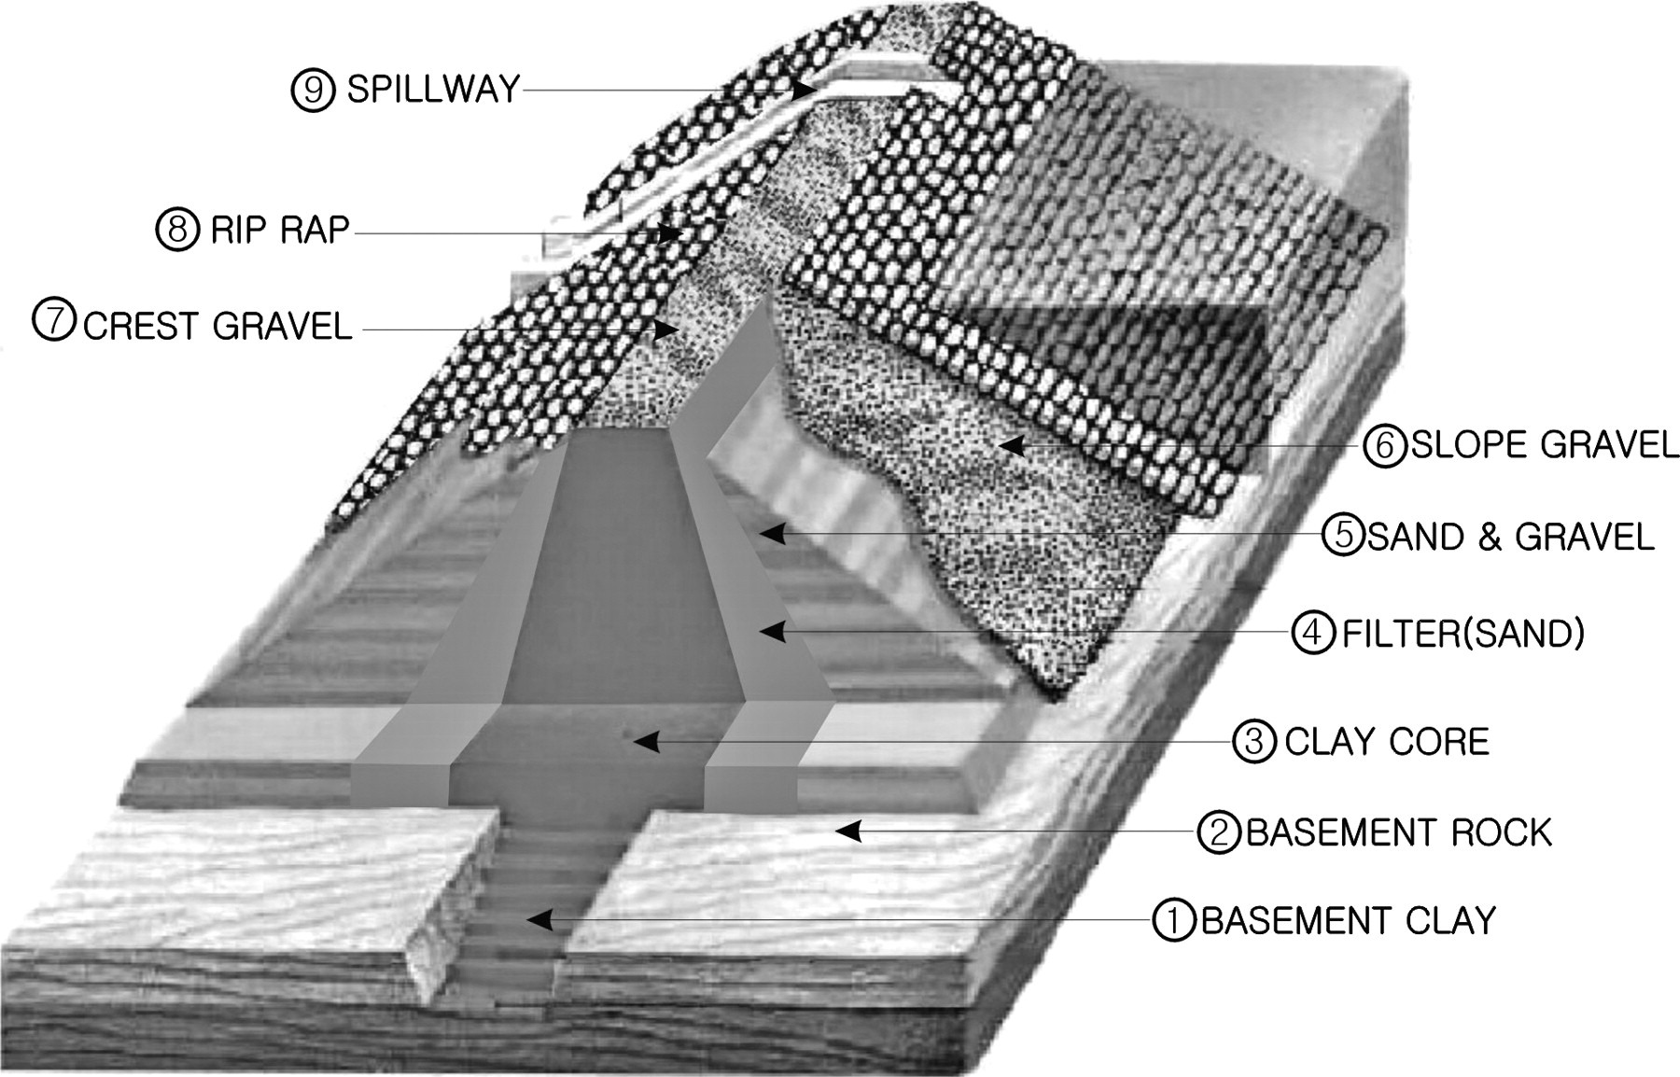

Title: Typical internal structure of an earth dam with central clay core. The earth consists of clay core, sand, gravel, and riprap, whose physical properties are significantly different.

Source: http://jeeg.geoscienceworld.org/content/12/2/221/F1.full

Properties of Earth Materials

Porosity: It is a measure of the void (i.e., "empty") spaces in a material, and is a fraction of the volume of voids over the total volume, between 0 and 1, or as a percentage between 0 and 100%.

In general, total porosity values for unconsolidated materials lie in the range of 0.25-0.7 (25%-70%). Coarse-textured soil materials such as gravel and sand tend to have a lower total porosity than fine-textured soils such as silts and clays. The table below show porosity values for typical earth materials.

Range of Porosity Values
Soil Type | Porosity
Unconsolidated deposits
Gravel | 0.25 - 0.40
Sand | 0.25 - 0.50
Silt | 0.35 - 0.50
Clay | 0.40 - 0.70
Rocks
Fractured basalt | 0.05 - 0.50
Karst limestone | 0.05 - 0.50
Sandstone | 0.05 - 0.30
Limestone, dolomite | 0.00 - 0.20
Shale | 0.00 - 0.10
Fractured crystalline rock | 0.00 - 0.10
Dense crystalline rock | 0.00 - 0.05
Source: Freeze and Cherry (1979).

Source: http://web.ead.anl.gov/resrad/datacoll/porosity.htm

Permeability: It is a measure of the ability of a porous material (often, a rock or unconsolidated material) to allow fluids to pass through it.

Hydraulic Conductivity: It is a property of vascular plants, soil or rock, that describes the ease with which a fluid (usually water) can move through pore spaces or fractures. It depends on the intrinsic permeability of the material and on the degree of saturation, and on the density and viscosity of the fluid.

Source: Wikipedia

Engineering Design

Synopsis of the Design Activity:

Goal: To create a water pond in a creek for fishing and water supply

Who is the client: Mayor of Lafayette

What is the design: A simple earthen dam

Criteria (list): (i) The dam should be constructed by using at least two types of earth materials; (ii) Hold water for at least 1/3 to 1/2 the height of the dam; (iii) Hold the water for at least five minutes before leaking; and (v) should be triangular in shape (top smaller than the base)

Constraints (list): (i) Only available earth material should be used in constructing the dam.

Lesson Plan #1
Enquiry Activity – testing the properties of earth materials

Time: 30 minutes

Note: In this lesson students will learn two key properties of earth materials, including water retaining or holding capacity and stability.

Procedure:

- Before the class, the teacher needs to prepare the material required for this activity. Assuming four students in each group, prepare the following for each group:

- Water draining cups: Punch or drill holes at the bottom of three plastic cups. Make sure the configuration of holes (size, numbers and spacing) is consistent among all cups. Insert a coffee filter to block the holes. Fill half of one cup with potting soil, half of another cup with sand and the half of another cup with gravel.

- Cups for testing stability: Have three more empty cups without any holes.

Prepare a working station (a table should also work) that will have some wet sand, potting soil, gravel, two plastic measuring cylinders, two stop watches, one container filled with water and one empty container .

- Start a whole class discussion focusing around the following key questions:
- Do you know any earth materials?
- Where do you think earth materials come from?
- What’s the difference between manmade and earth materials?
- Do you use earth materials in everyday life?
- Do you know anything made from earth materials?
- What else do you know or want to know about earth materials?

- Before the enquiry activity, seek three student volunteers to help with this task. At the working station, the teacher and the student volunteers will perform the following enquiry activities:

- Testing the water retaining or holding capacity of earth materials: Have one student volunteer hold the water draining sand cup above another empty cup, have the second student volunteer fill the sand cup to 3/4th, and have the third student watch the time for one minute. During this time, water will drain from the sand cup into the empty cup. After one minute, measure the water drained in the empty cup. Ask all students in the class to fill out the information in Table 1 (next page). After measuring, discard the drained water into the empty container. Repeat this for both potting soil cup and gravel cup. Encourage students to change roles.

- Testing the stability (ability to withstand forces) of earth materials: Have one student in each group to fill and compact an empty cup with potting soil, have another student do the same with sand, and have the third student do the same with gravel. After the three cups are filled, have them flip the cup against the table surface, and slowly lift the cup without disturbing its contents. Ask each student in the class to rank the stability of each material from 1 to 3 with 1 being most stable and 3 being least stable.

- After all groups complete their Table 1, have students describe which material is best at holding water, and why. Similarly, ask which material is more stable, and why.

Table 1

Material | Amount of water drained (milliliters)
Potting soil
Sand
Gravel

Material | Stability Rating/Ranking (check one box)
 | very stable (does not fall under any pressure) | stable (falls under pressure) | unstable (does not stand even without any pressure)
Potting soil
Sand
Gravel

Lesson Plan #2
Guiding Question – Designing an Earthen Dam

Time: one 30 minute class session

Procedure:

- Begin the class by briefly reviewing the properties of earth materials the students learned in Lesson 1.

Introduce the challenge “Your fish loving neighborhood is concerned about the Fishy Creek because it is running dry for several months. In order to get fish, the creek needs to retain some water when it rains in the future. As future engineers, the mayor of Lafayette has asked you to design an earthen dam to retain the water in the Fishy Creek”

After introducing the challenge, give a brief overview of an earthen dam and some of the nomenclature associated with it such as the height, depth, width, rip-rap, etc. Use the materials in the resources to help with this explanation.

Next introduce the criteria and constraints. The design must satisfy the following criteria and constraints:

- Guide students through the design activity.
- What is the goal?
- Who is the client?
- Are there any criteria? What are they?
- Are there any constraints? What are they?

- Form teams of 2 to 3 students. Review team rules and expectations (see examples below)
  - Everyone contributes with all tasks
  - Professional behavior
  - Safety

- Introduce the materials available for building the dam to the class.

- Have each group work on a design of the dam, and come up with a drawing with labels indicating the size (dimensions) and the materials.

Lesson Plan #3
Guiding Question – Building an earthen dam

Time: one 30 minute class session

Procedure:

- Students will begin by reviewing and presenting their design sketch for the dam

- Based on their design sketch, have each group gather the needed materials.

- Have each group build their dam. Ask them to write down any changes they made to their original design during the actual building. Also list any new material that was used.

- After the design ask each group to come to the station and test it by pouring required amount of water. Each group should pour water at least 1/3 to 1/2 the depth of the dam. The dam should hold the water for at least 5 minutes without leaking or seepage.

Assessment/Wrap-up

Check if the students understand what properties of earth materials are useful in building dams?

Wrap up the activity by discussing the following:

- Have students comment on different designs
- Why some dams worked better than others
- What is the effect of materials used in the design,
- What kind of changes they would make to the design to improve the quality of their dam.

Lesson Extensions and Resources

Activity Extensions: Lesson 2 and 3 can be extended to optimize the design and construction of the dam by associating cost for all the materials that will be used in building the dam.

Alternative design brief based on Human Survival aspect of the science standard:

Your local community gets water supply from a nearby river. However, due to the recent drought, the river is running dry. In order to maintain water supply to the community, it is critical to hold water in the river when it rains in the future. The mayor of Lafayette is looking for someone to design an earthen dam to retain the water in the river. The dam must satisfy the following criteria and constraints:

Resources:

Web Links:

Design Activity
Student Resource

Designing an earthen dam for the city of Lafayette

You want to go fishing at the creek near your school, but it is running dry for several months. In order to get fish, the creek needs to retain some water when it rains in the future. The mayor of Lafayette is looking for someone to design an earthen dam to retain the water in creek. The dam must satisfy the following criteria and constraints:

Criteria:

The dam should be constructed by using at least two types of earth materials

Hold water for at least 1/3 to 1/2 the height of the dam.

Hold the water for at least five minutes before leaking

Should be triangular in shape (top smaller than the base)

Constraints:

Only available earth material should be used in constructing the dam.

