Student directions for a whiteboard prompt and enzyme experiment:
Guided Inquiry: Enzyme Catalyzed Biomass Conversion Reactions

1.) Choices for starting materials: Bread, Strawberry, Blueberries, Pretzel, Lactose, Beans, Milk, Pineapple, and how much with 100mL of water.
Guidelines for starting materials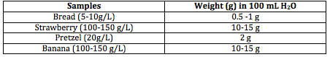
2.) Chose your enzyme and amount: Beano, Lactase, Yeast, Saliva, Meat Tenderizers (Papain, Bromelain)
3.) What will you measure as the product? Glucose, CO₂ Gas Pressure (only yeast + sugar)

Control: Should match Trial #1 but have no _________________________.
Trial #2: What will you change in the experiment to test a variable (heat, cold, acid, more enzyme, different enzyme? more substrate?) What are your predictions?

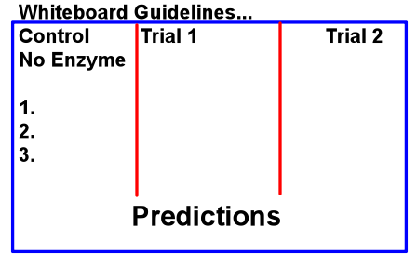

Get approval of your experiment and data table on the whiteboard, then record the experiment plan on paper (each member).

