Grade Level:  6th | Total Time Required:  3 periods (90 minute each), approximate
Prepared By: Kari Clase, Melissa Colonis, John Grutzner, Bryan Hubbard, Alyssa Panitch, and Nancy Tyrie

Lesson Objectives:
Students will be able to:

- Demonstrate that the seasons in both hemispheres are the result of the inclination of the earth on its axis, which causes changes in sunlight intensity and length of day.
- Identify the difference between direct and indirect rays of light.
- Apply their understanding of indirect and direct rays to design a device that can be used to track the sun through the day and various times of the year.
- Use various materials and typical engineering design components (examples provided).
- Measure the angles associated with the inclination of the sun and position of the sun throughout the day.

Indiana Standards:

Content Specific:
- Science 6.2.5 (Earth and Space Science)
Demonstrate that the seasons in both hemispheres are the result of the inclination of the earth on its axis, which causes changes in sunlight intensity and length of day.

Mathematics Connections:
The design activity requires the students to perform the following mathematical calculations:
- The measurement of the horizontal angle of the solar panel on their completed design to show the design functions for the sun crossing the sky from East to West.
- The measurement of the vertical angle to show the design functions for the change of sun angles from the summer to the winter.
- Measurement of elapsed time.

Concepts and Vocabulary

Science Concepts / Vocabulary:
Term | Defined by a scientist or engineer | Defined by a 6th grade student
Axis | An imaginary line around which an object rotates. In a rotating sphere, such as the Earth and other plants, the two ends of the axis are called poles. | An imaginary line that goes through the center of the earth.
Solar | Relating to the sun | Sun
Solar Panel | (Engineering/Electrical Engineering) A panel exposed to radiation from the sun, used to heat water or, when mounted with solar cells, to produce electricity directly. | What is used to collect the sun’s energy.
Direct Rays | A direct ray is when the Sun's light hits the specified part of Earth that you are observing at an exact angle of 90 degrees . This means that the Sun's rays are perpendicular to the Earth; (Site: http://wiki.answers.com/Q/What_is_the_definition_of_direct_rays ) | The sun is directly overhead and there is no shadow.
Indirect Rays | Indirect rays are when the Sun's light hits the specified part of Earth at an angle other than the perpendicular angle of 90 degrees. | The sun’s rays are coming at me from the side and there is a shadow.

Equipment, Materials, and Tools

List the quantities of all materials and equipment needed:
Materials for a class of 20 students with 4 in each team (They will not use all materials).
Tools/Equipment | Materials
Rulers | Marbles (50) | Round plastic plates (20)
Scissors | Plastic cups (20) | Golf balls (8)
Flashlight | Vinyl corner bead pieces (50) | Clay (1 pkg)
Electrical clips and leads | Flexible straws (4) | Brass paper brads (100)
Multimeter* | Duct tape (2 rolls) | Small Solar Panel** (5)

*Equus 3300 hands-free Digital Multimeter (~$13.00 at Walmart)

Special Materials Notes and Comments

**Small solar panels are available on the following websites:

http://www.allelectronics.com/make-a-store/item/SPL-61/SOLAR-CELL-60MM-X-60MM-X2MM/1.html
http://www.futurlec.com/Solar_Cell.shtml

In addition to purchasing them on-line, you may also purchase inexpensive solar lights at a hardware store and remove the solar panel. Note: Some are easier to remove than others. You may want to try a couple of different varieties to see which solar panels come out the easiest.

Science Content

Science Content:

Why do you need to design a solar panel that can move?

  - Sunlight intensity and length of day changes because the earth is tilted on its axis. During the summer in the Northern Hemisphere the north axis is tilted towards the sun and the sun’s rays hits that part of Earth more directly. The Northern Hemisphere is tilted away from the sun during winter and therefore the sun’s rays hit that part of earth less directly

  - In order for the solar panel to be as efficient as possible, the panel needs to be pointed towards the sun during the day and also be angled correctly for the seasons. The solar panel will still function if it is not exactly pointed at the sun, however, the efficiency decreases.

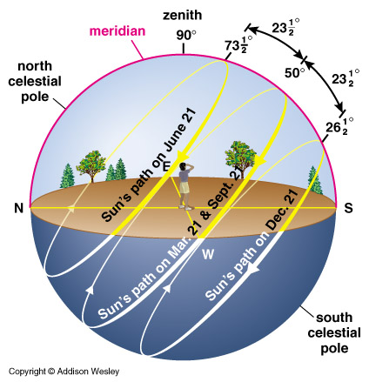 | 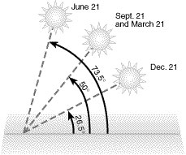
Sun angle at various times of the year (http://curious.astro.cornell.edu/images/pathofsun_40deg.jpg ) | http://parametricmodel.com/upload/image/full_4d4040fdc802a.jpg

Direct and Indirect Sunlight

The website “The Reasons for the Seasons” by Gary Becker provides an excellent review on why we have seasons and the concepts of direct and indirect light. The link to the website is: http://www.astronomy.org/programs/seasons/index.html#reasons

Excerpts from the website are provided below:

“Imagine the flashlights to be the sun. The energy coming from each flashlight is the same, but the way the light is striking the ground is different. The two flashlights on the left are allowing their energy to strike the ground DIRECTLY in a concentrated manner. The flashlight on the right is tilted so that when its energy strikes the ground, the energy is spread over a much larger area. The energy from the tilted flashlight is striking the ground INDIRECTLY, and its energy is less concentrated.”

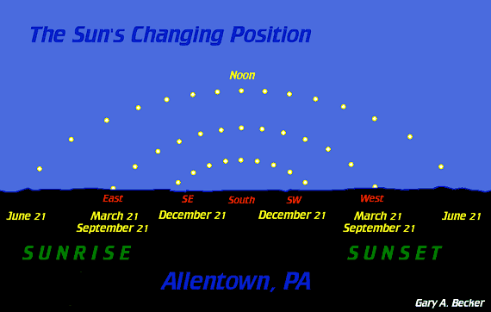

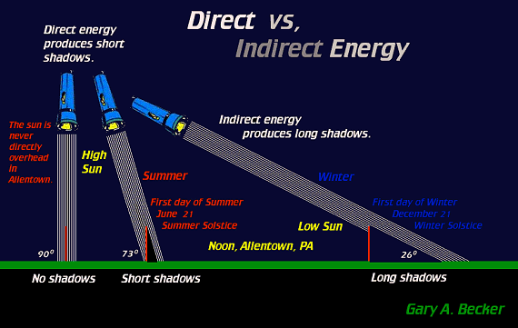

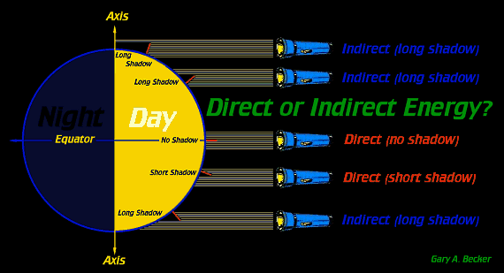

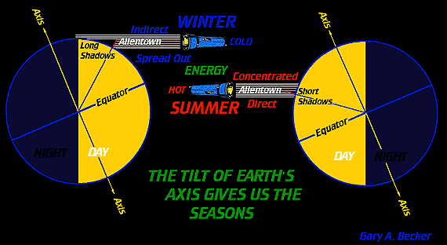

Lesson Plan #1
Guiding Question – How does a solar panel move? What are the common principles?

Time: Two 90 minute class sessions

Procedures / Steps:

Introduction of Design Task

- Introduce design task and information on the client (Design Activity, Student Resources) by distributing the desk task to students.

- Ask: What is the problem?
Who is the client?
Who is the end user?
What are examples of constraints?

- Before students begin their plans, discuss important science principles that need to be understood in order to perform the design task. These are listed under the “Science Content” section.

Ask: How do we get the four seasons?
If I put a diagram on the board, how or where should I put the sun? Where should I put the Earth?
Now let’s look at our diagram, what time of year is it?
Where would the sun be if it was fall in Indiana?
Where would the sun be if it was winter in Indiana?
Where would the sun be if it was spring in Indiana?
Where would the sun be if it was summer in Indiana?

Explain to students that there are three central ideas related to the seasons: 1) the tilt of the Earth; 2) the direction of the sun’s rays (indirect vs. direct); and 3) the path the Earth takes around the sun.

- Before proceeding, ensure students understand the reason we have seasons and how the sun crosses the sky during the day.

Ask: Using a model of the Earth, how would we position the Earth relative to the sun when it is winter in Australia?
Using a model of the Earth, how would we position the Earth relative to the sun when it is summer in Alaska?

Initial Design Brainstorming:

- Introduce components that they can use to build the solar tracking device. (This is a very open ended project and there are many ways to fabricate a working model)

- Introduce concepts on how the solar panel can move using typical mechanical design components, such as ball bearings and four bar linkages.(See Mechanical Design Components Section)

- Instruct students to sketch his/her possible designs for a solar tracking system in their design books.

Ask: What are the important features of your design?
How will you use some of the materials in your design?
What are some challenges or problems you think your team may face?
How could address these problems now?

- Instruct each team to decide on one plan after they share their designs. The design could be a specific design of one student or a combination of designs.

- Students will then construct one prototype per team. Allow for 90 minutes for construction.

- A list of items and potential monetary value is provided. Students may be asked to determine how much their design costs and they can “buy” additional items, if needed.

Assessment

The following are possible sources of formative and summative assessment:
- Design notebooks (individual) – Note how students identify and clearly label their drawings; Identify the types of science vocabulary students use in their notebooks (tally the number of times each concept is used); Note how students record data from testing their prototypes and how well they explain their results (patterns in the data)
- Presentation of design to class by the team. Provide positive design attributes, how design criteria where met, and possible redesigns.
- Participation (group) – Note level of engagement; questions students asked; how well they worked in a group; how well each team met the goals of the task
- Other (individual and/or group) – Create a short pre and posttest that highlights key science vocabulary terms; Present a new situation or new problem on the same theme
- See Lesson Extensions

Lesson Extensions and Resources

Activity Extensions:
http://science-class.net/Notes/Notes_Seasons_7th.htm
Provides a clear explanation of terms, concepts, and ideas related to students’ conceptions of the four seasons. This site also provides ideas for extension activities on topics related to Earth’s rotation, four seasons, and planetary motion.

Web Resources:
http://education.nationalgeographic.com/education/activity/the-reason-for-the-seasons/?ar_a=2
National Geographic Education – provides an excellent short video of the reasons for the seasons. Also provides additional learning activities and handouts for teachers.

http://astro.unl.edu/naap/motion1/animations/seasons_ecliptic.html
University of Nebraska at Lincoln provides a season simulator that shows the earth/sun relationship at any time and latitude throughout the year.

Design Activity
Student Resource
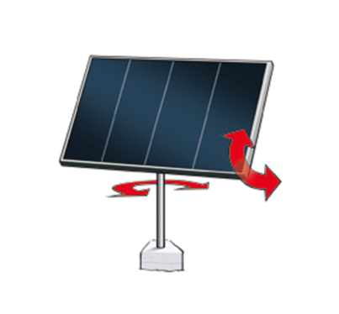
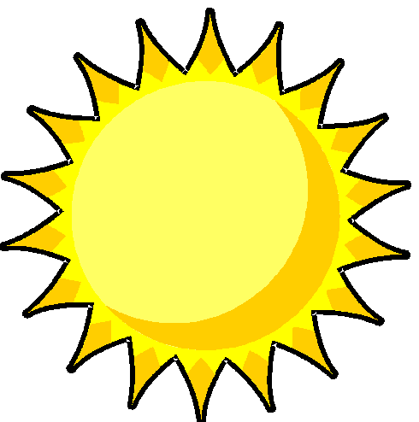
Indiana Solar Power Company needs your help. They are interested in finding a way to obtain as much energy as they can from the sun. One way is to use solar panels. In order to maximize the amount of solar energy collected by the solar panels, the panels must be positioned such that they face the sun at all times of the day and during all seasons. The Indiana Solar Power Company believes your team can help.

The company is asking you to develop a solar panel system that can be easily moved to track the sun, so that the panel can collect as much solar energy as possible. To complete this task you need to use what you know about the sun’s location in the sky during different times of the day and during different seasons. You may also want to use what you have learned about how machines move.

Design Constraints
- The solar panel should be able to move horizontally to track the sun through the day.
- The solar panel should also be able to be moved vertically to capture the different angle of the sun during summer and winter. (See Figure 3)
- The solar panel does NOT have to move on its own (motors are not provided), however, students can assume that a product would use a motor or other system to move the solar panel.

Possible cost for items to link with a classroom economy
Marbles | $2 Each
Plastic Cups | $10 Each
Vinyl Corner Bead Pieces | $5 Each
Bendy Straws | $15 Each
Duct Tape | Free
Round Plastic Plates | $10 Each
Golf Balls | $4
Clay | $20 (As much as needed)
Brass Paper Brads | $1 Each
Small Solar Panel | $100
Mechanical Design Components

Ball Bearing Information
- Things tend to roll better than they slide.
- Rolling friction has less resistance than sliding friction.
- The balls or rollers “bear” the load in a ball bearing (shown below).
- Balls can be put between to surfaces to decrease sliding friction. Examples of how they can be built for this project are shown in the following pages.

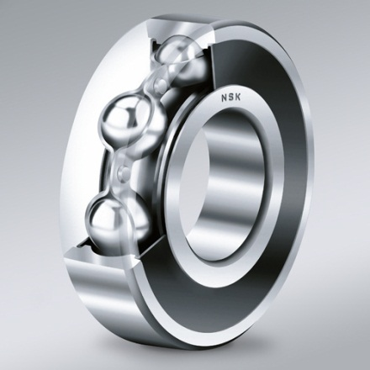
Ball Bearing Image
http://www.nskeurope.com/cps/nsk/eu_en/p/images/content/1030_DGBB_rgb_rdax_95.jpg

Four-Bar Linkage
A typical engineering design component to move something is a four-bar linkage. A four-bar linkage consists of four pieces of material connected in a loop by joints. In the image below, three links are shown. The fourth would be connected between the ground pins (grey bases) and is not shown because it would not move.

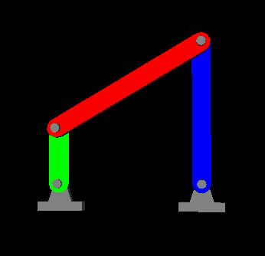
Four Bar Linkage Image
http://www.robotics.utexas.edu/simulations/images/FourBar.jpg

Note: The bars do not have to be the same length. The students may change the lengths of the various bars to get different effects.

An animation of a four bar linkage can be found at:
http://www.robotics.utexas.edu/simulations/Subjects/Mechanisms/Four%20Bar/index.htm

Possible Designs
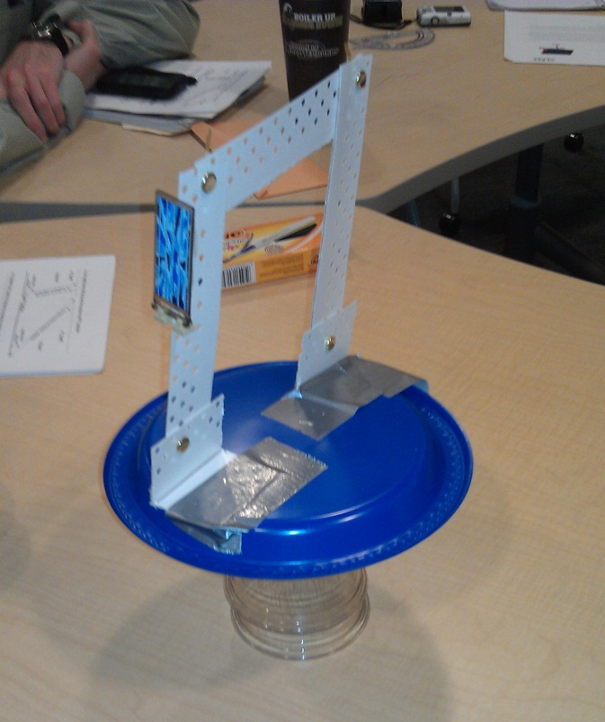 | 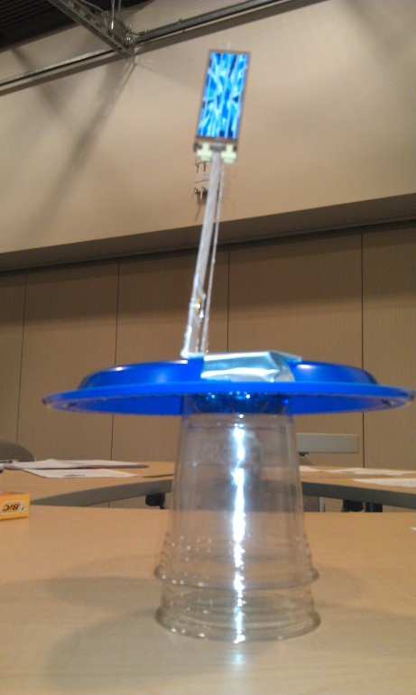
Solar Tracker utilizing ball bearings(Marbles between cups) and 4 bar linkage

Solar Tracker utilizing foam and duct tape

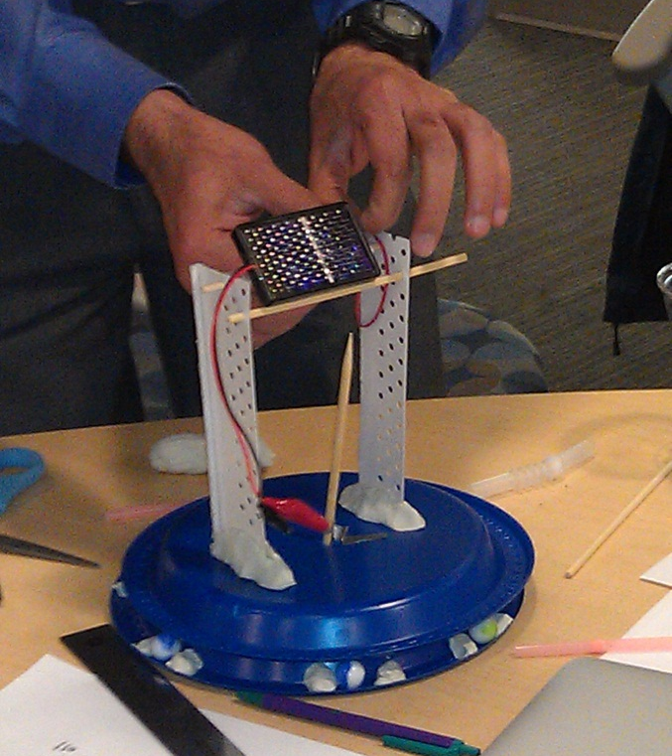
Solar Tracker utilizing ball bearing between two plates and rotating shaft to provide vertical alignment

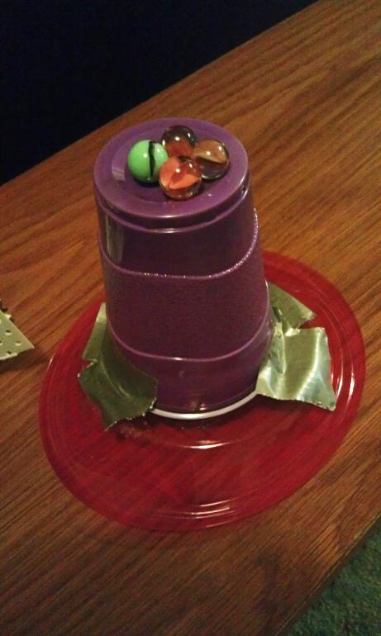 | 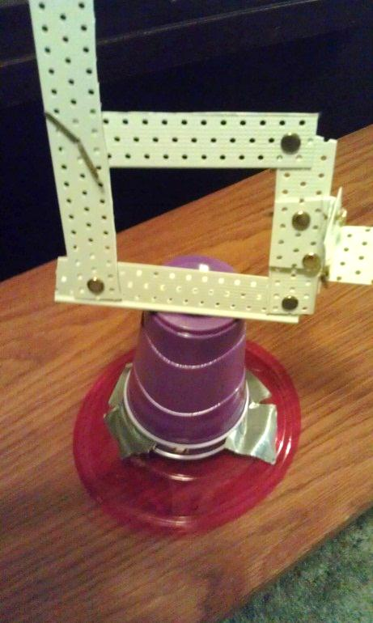
Solar tracker utilizing ball bearings and 4 bar linkage

Lesson Plan #2
Guiding Question – How can you measure the angle of your solar panel device? How well does your device track the sun crossing the sky?

Time: one 90 minute class session

After the prototype is built the student can measure angles of the solar panel to show the design functions as required by the client.

- First measure the vertical angle of the solar panel to show the design functions for the change of sun angles from the summer to the winter. The winter angle is 26.5 degrees and the summer angle is 73.5 degrees. Note: angle of ray is provided, solar panel is perpendicular to ray.
- If an electrical multimeter has been purchased, a flashlight can be set-up at the angle for the sun. The students can see the change in voltage if the solar panel is not directly in line with the beam of the flashlight.
- Measure the horizontal angle required that the device needs to move to capture the sun rays as the sun moves from East to West (horizontal plane).
- The students can again use the multimeter to see the change in voltage output.
- Other angles can be determined for other dates from: http://solardat.uoregon.edu/SunChartProgram.html

Approximate Sun Angles from Horizontal at certain times of the year.
Date | Angle
December 21st (Winter Solstice) | 26.5 Degrees
June 21st (Summer Solstice) | 73.5 Degrees

